Clustering Maximo 7.1.x with IBM WebSphere 6.1

Multiple Application Servers can be created to cluster like functionality in Maximo. For example a group of Maximo Servers for the UI, a group for cron task, a group for integration, etc. A Maximo EAR file is deployed to the cluster and each cluster member runs that application. Each Application Server points to the same Maximo database. These Application Servers can be created on the same physical server as well as different physical servers.

There are a number of hardware and software solutions for load balancing. This guide does not cover load balancing it goes through the process of creating a cluster. With the installation of WebSphere a web server is also installed and you can use that to round robin the Maximo user sessions.

Paths and file names used in the document are defaults from the WebSphere install using the Maximo middleware installer and Maximo installation released February 2010 or later. This guide assumes the Maximo installation has occurred by following the Maximo installation guide.

Configuration

This configuration will include three Maximo Application Servers configured on the same physical server. The example cluster created will be a UI cluster. Maximo properties will be set differently for clusters for other functions (i.e. cron, integration, etc.)

- Modify the maximo.properties and add the property to not run the cron tasks
  - Rename the ibm\smp\maximo\applications\maximo\properties\maximo.properties file
  - Copy the ibm\smp\etc\maximo.properties_orig file to ibm\smp\maximo\applications\maximo\properties\maximo.properties
  - Edit the maximo.properties file and add the following line
mxe.crontask.donotrun=ALL
  - Verify the other properties values are correct
  - Encrypt the properties file
    - From a command prompt change to the ibm\smp\maximo\tools\maximo folder
    - Run encryptproperties
- Build the Maximo EAR file
  - From a command prompt change to the ibm\smp\maximo\deployment folder
  - Create the EAR file, run buildmaximoear

- Log into the WebSphere Integrated Solutions Console
  - http://<servername>:9060/admin
  - login with administrative user

- Create the cluster
  - Expand Servers
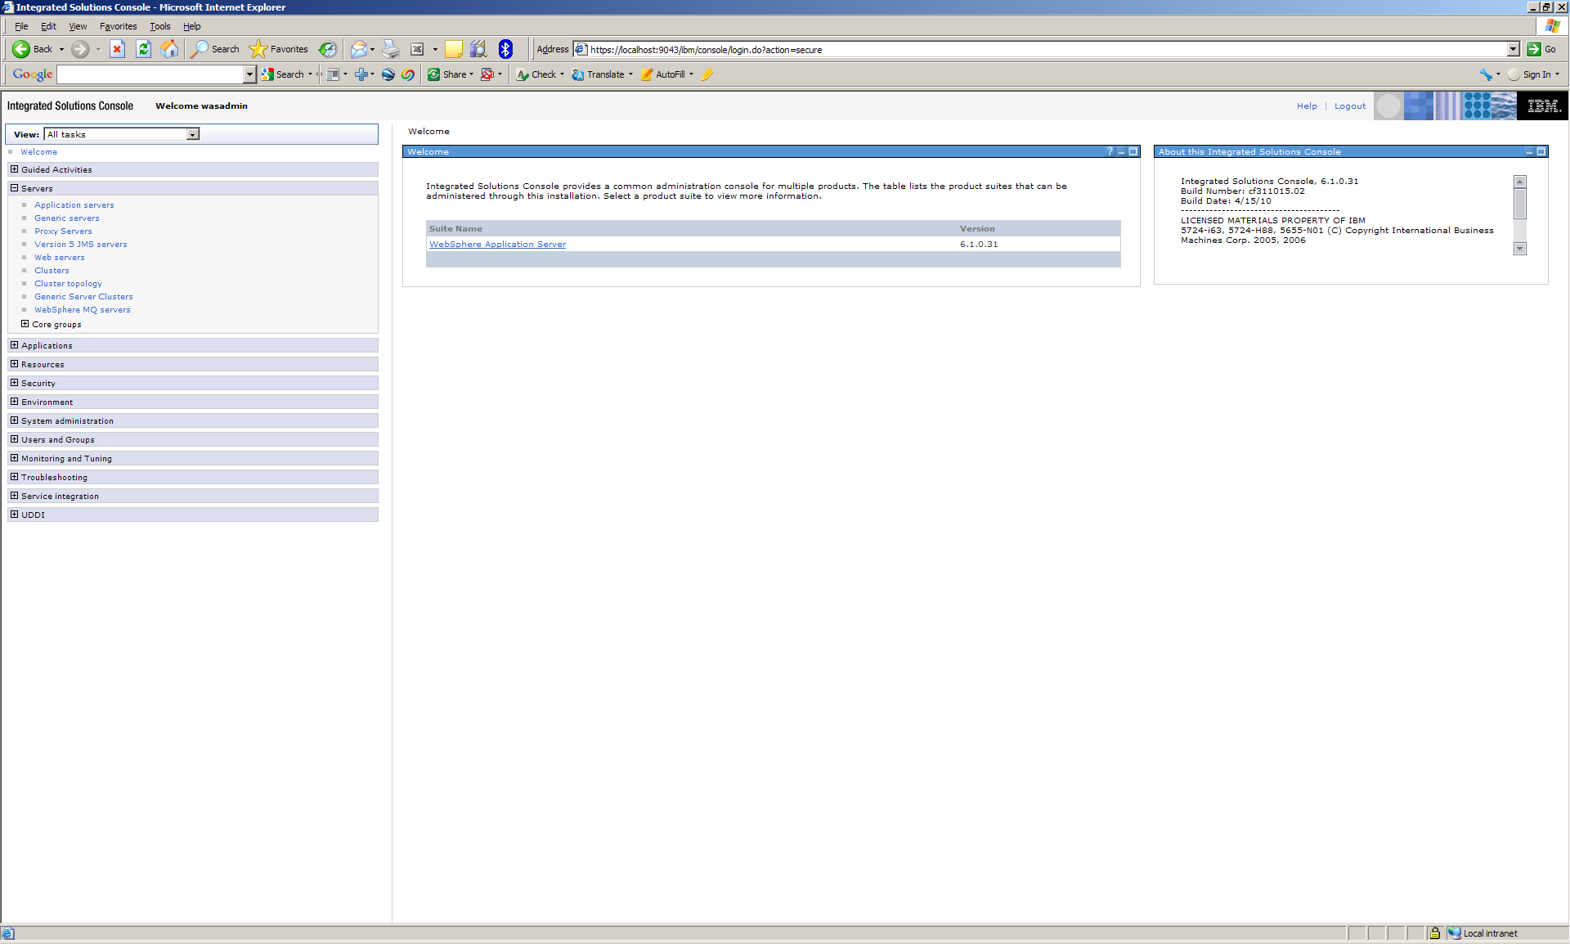

  - Select Clusters

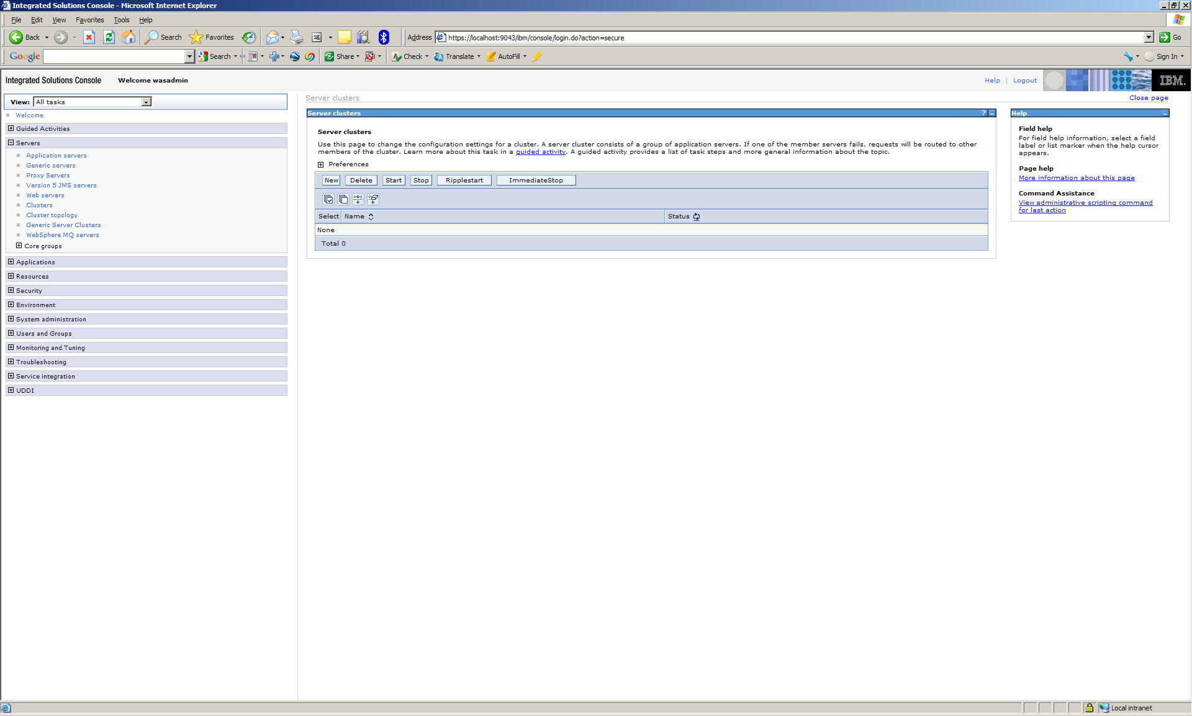

  - In the Server clusters section click New
  - Enter a name for the cluster and click Next

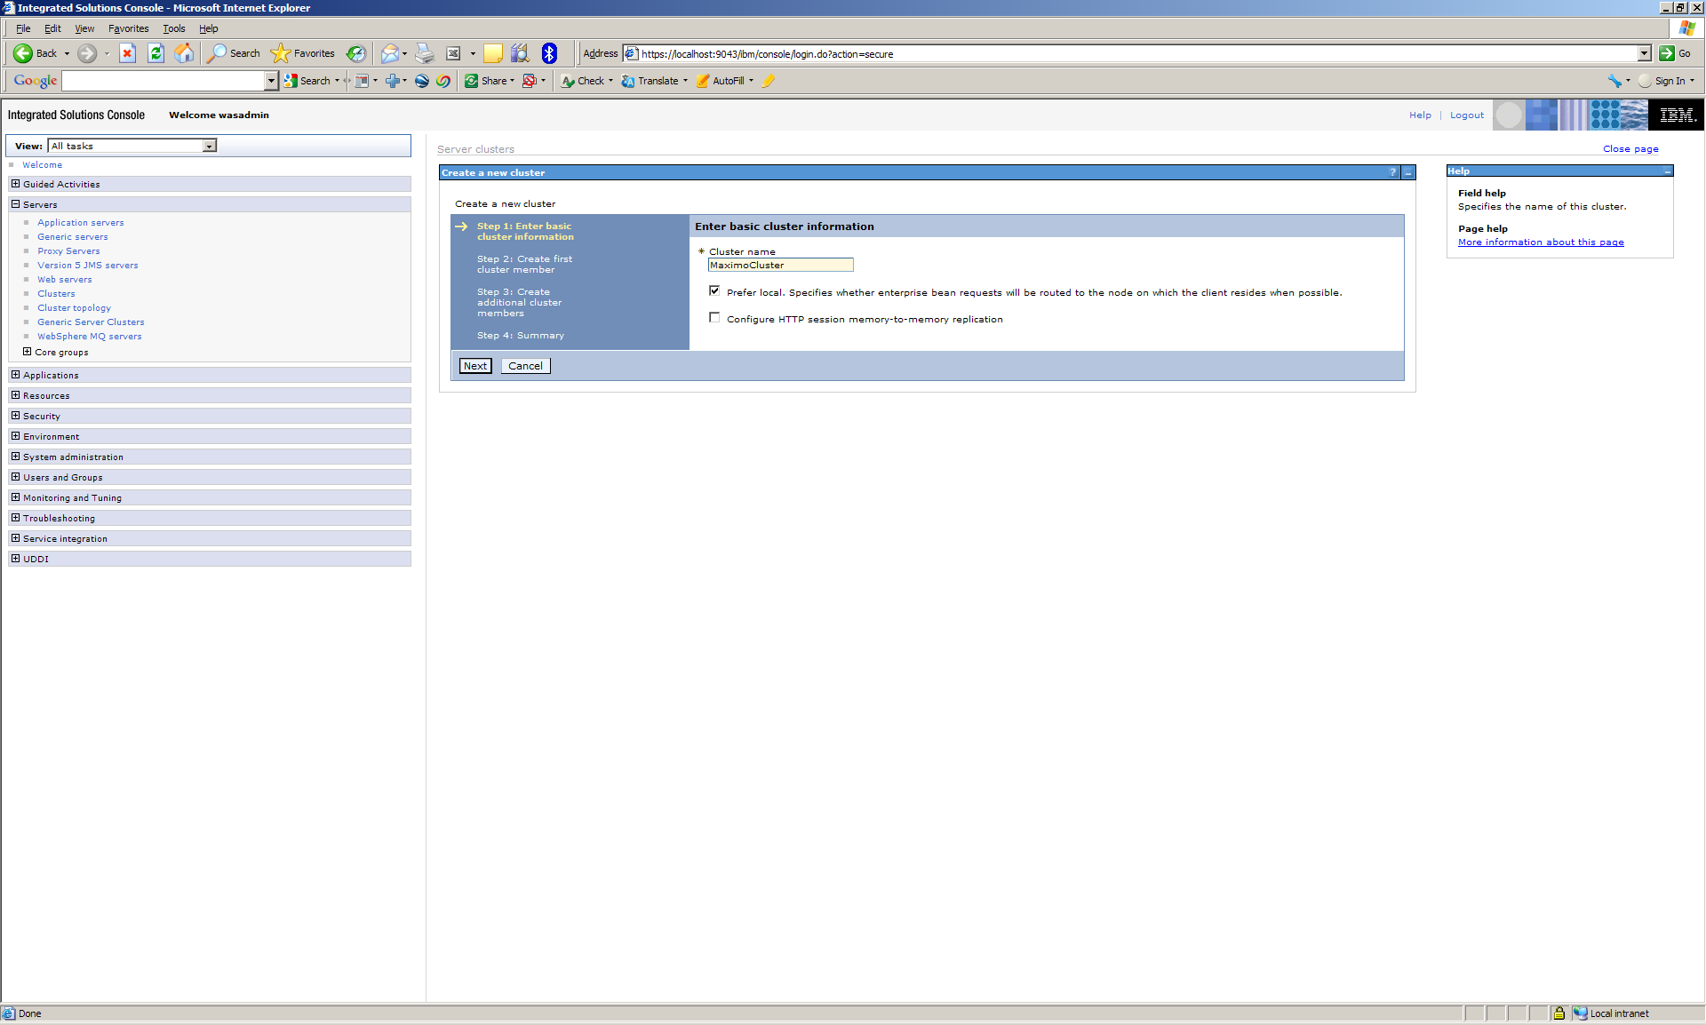

  - Enter the name of the first member of the cluster, click Create the member using and existing application server as a template and select the MXServer application server that was created during the Maximo installation, and click Next

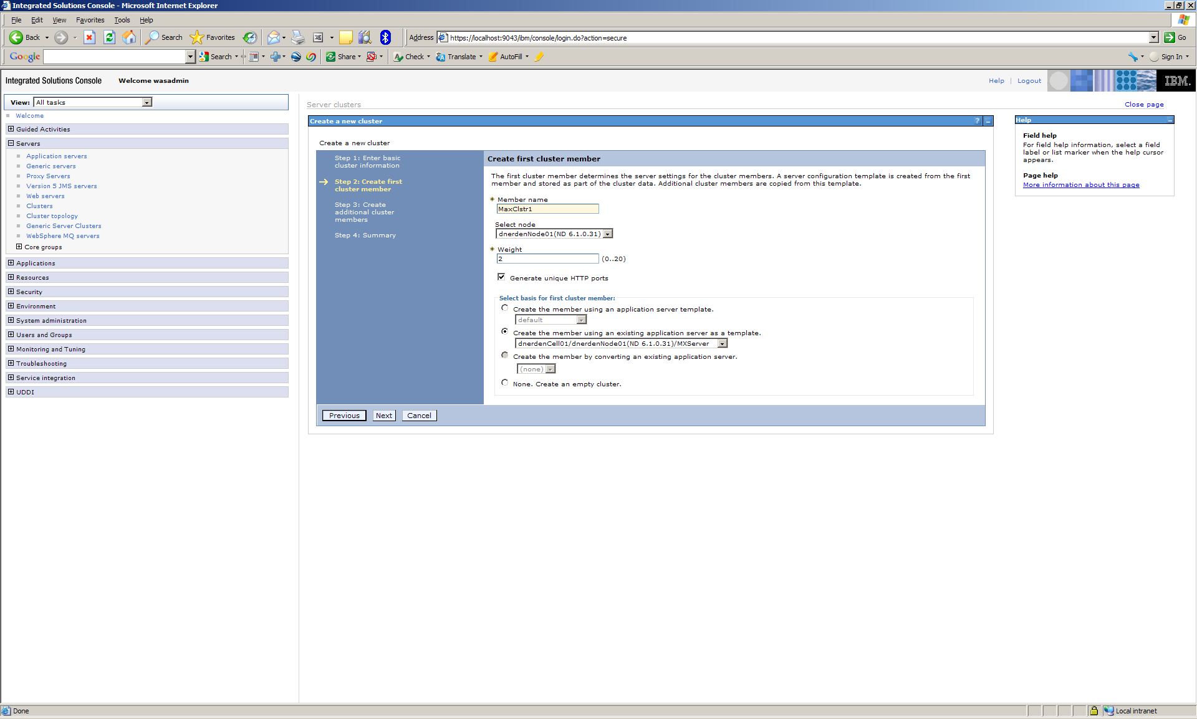

  - Enter the name of the second member and click Add Member

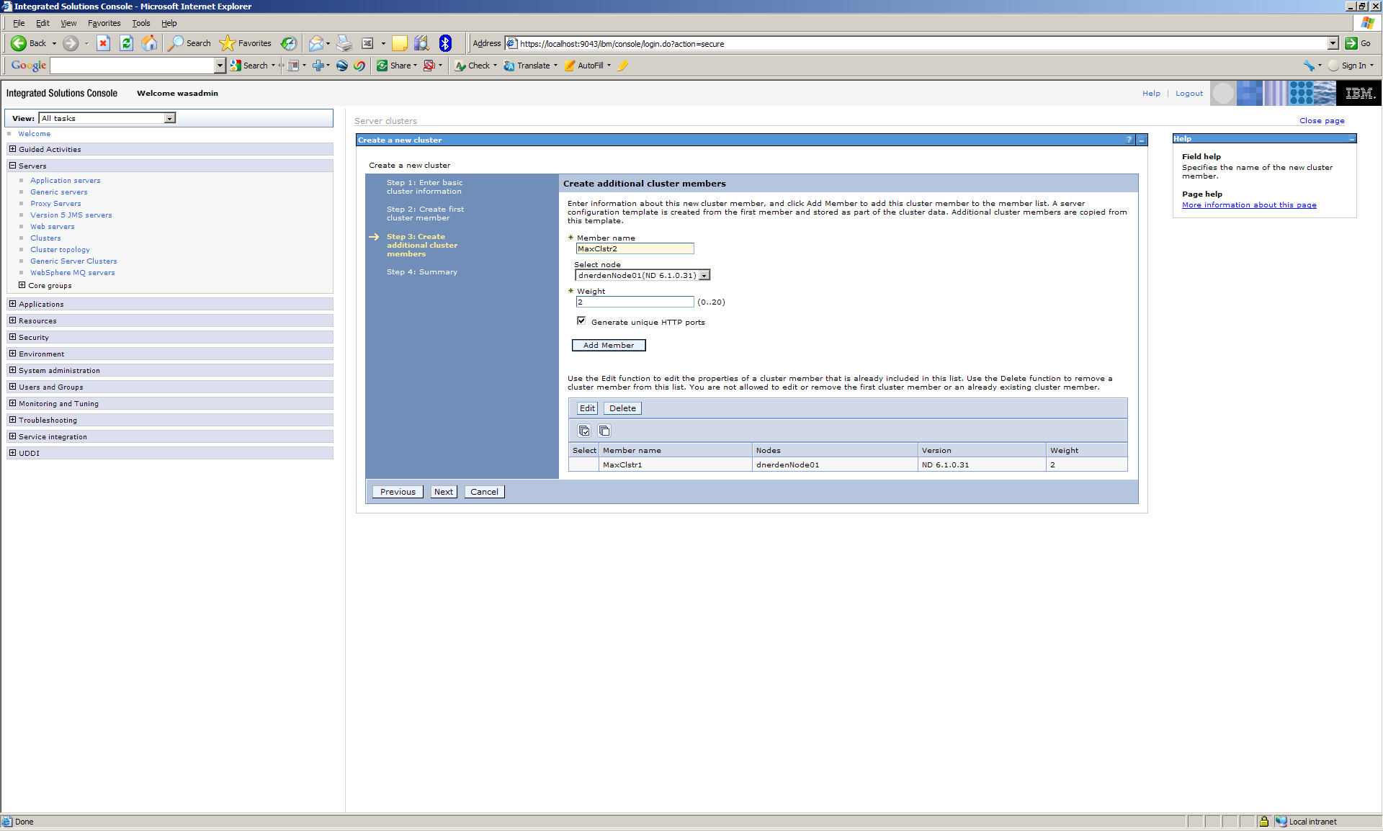

  - Enter the name of the third member, click Add Member, and click Next

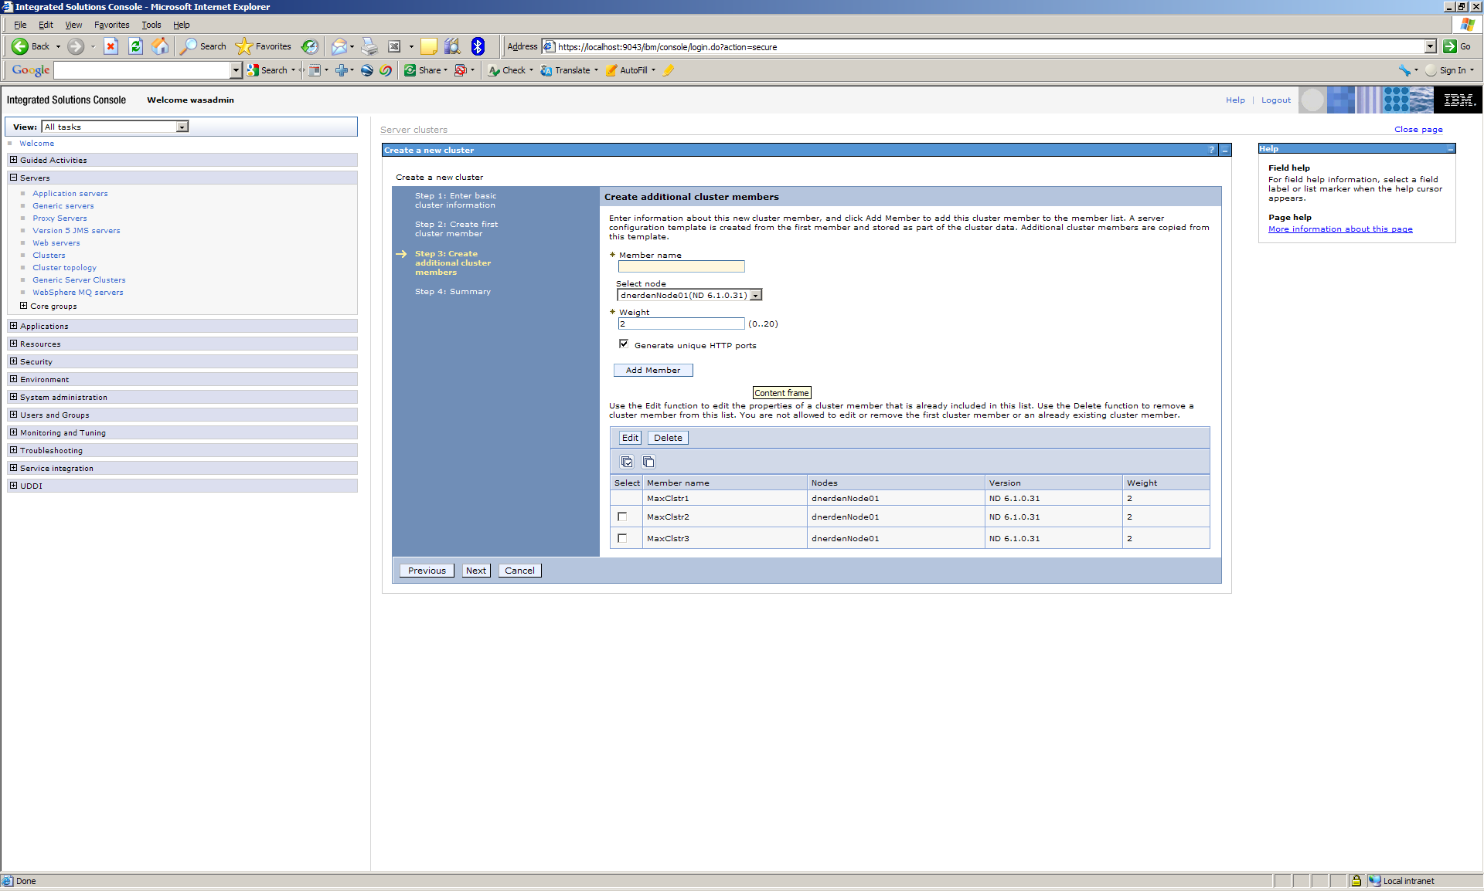

  - Click Finish

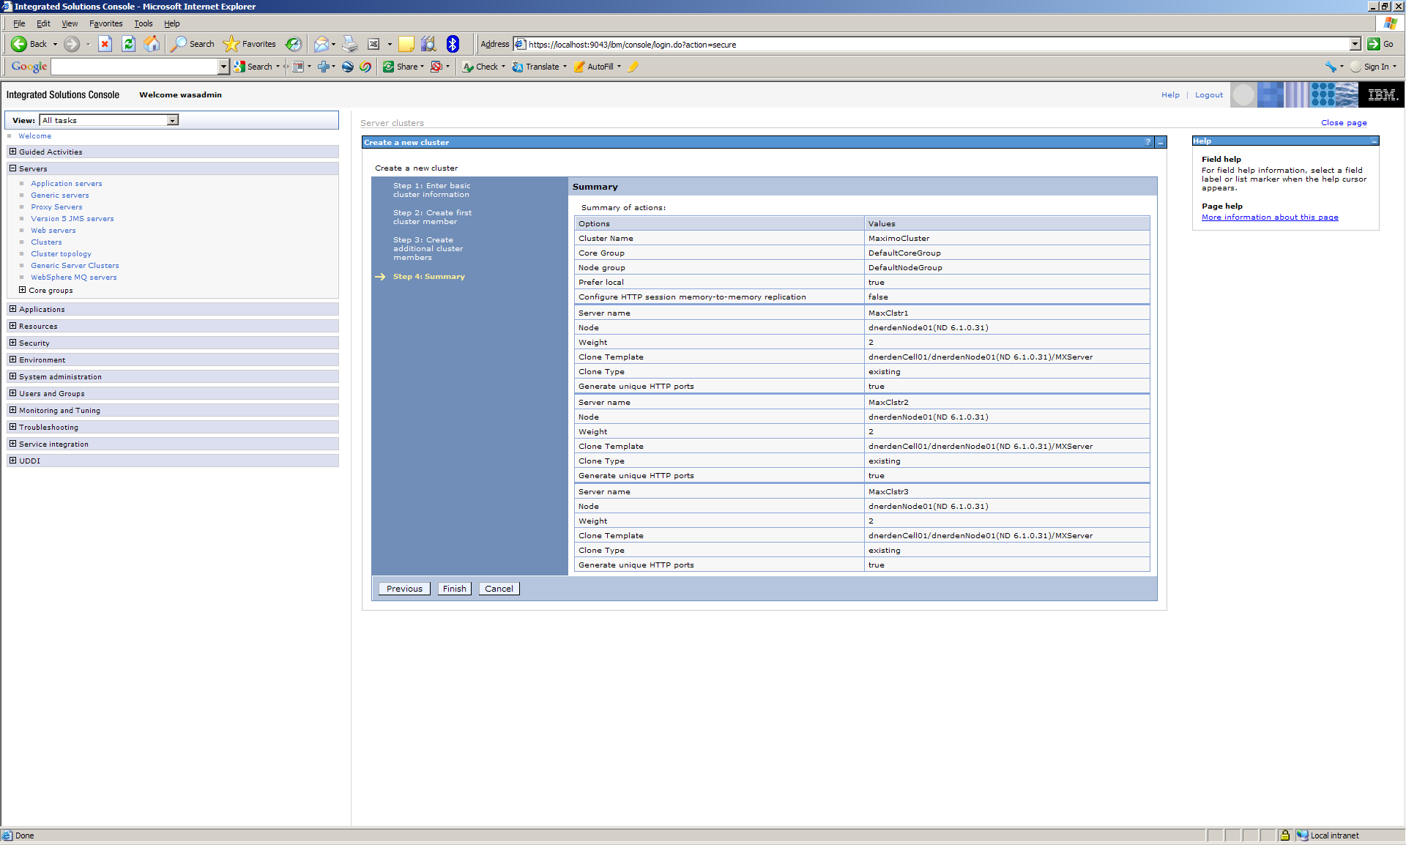
  - Click Save

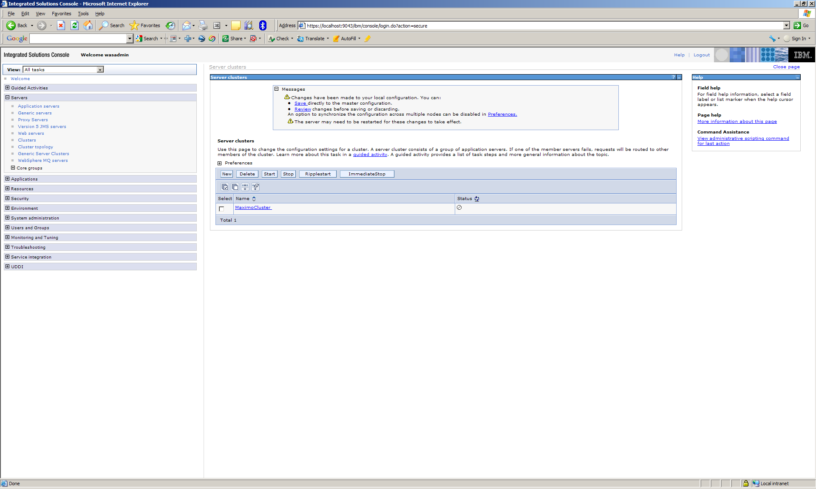

All settings on the MXServer application server used as the template have been applied to these cluster member application servers. You can verify the settings. You will now see the cluster members listed at application servers.
  - Click Application Servers. Click each application server to review settings.

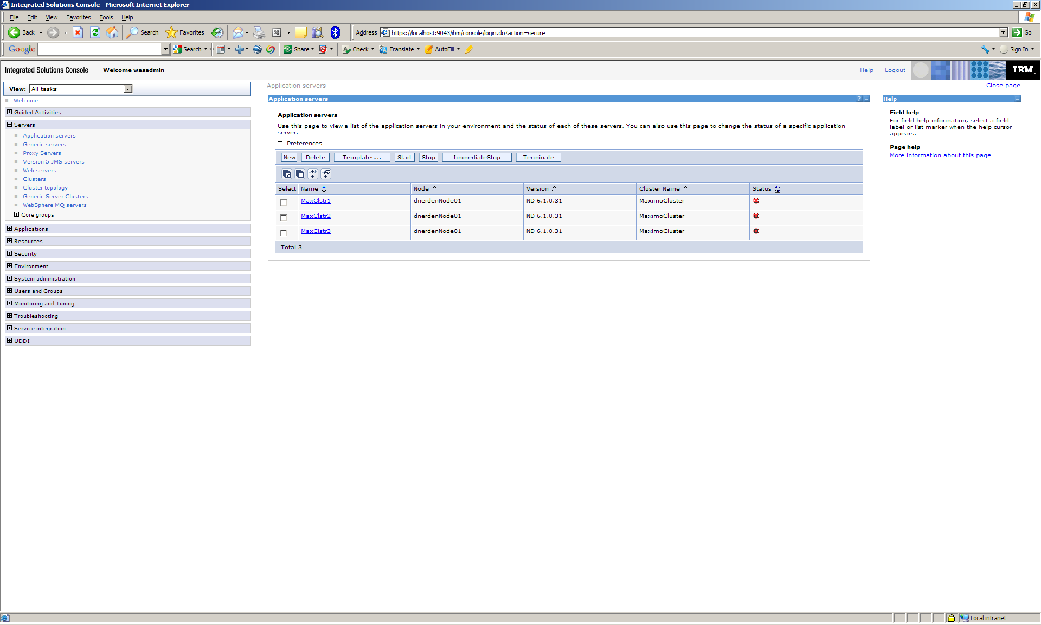

- Create the Virtual Host
  - Get the port numbers of the cluster member application servers. The port number with increase by 1 for each application server created.
    - Expand Servers and click on Application Servers
    - Click the first cluster member
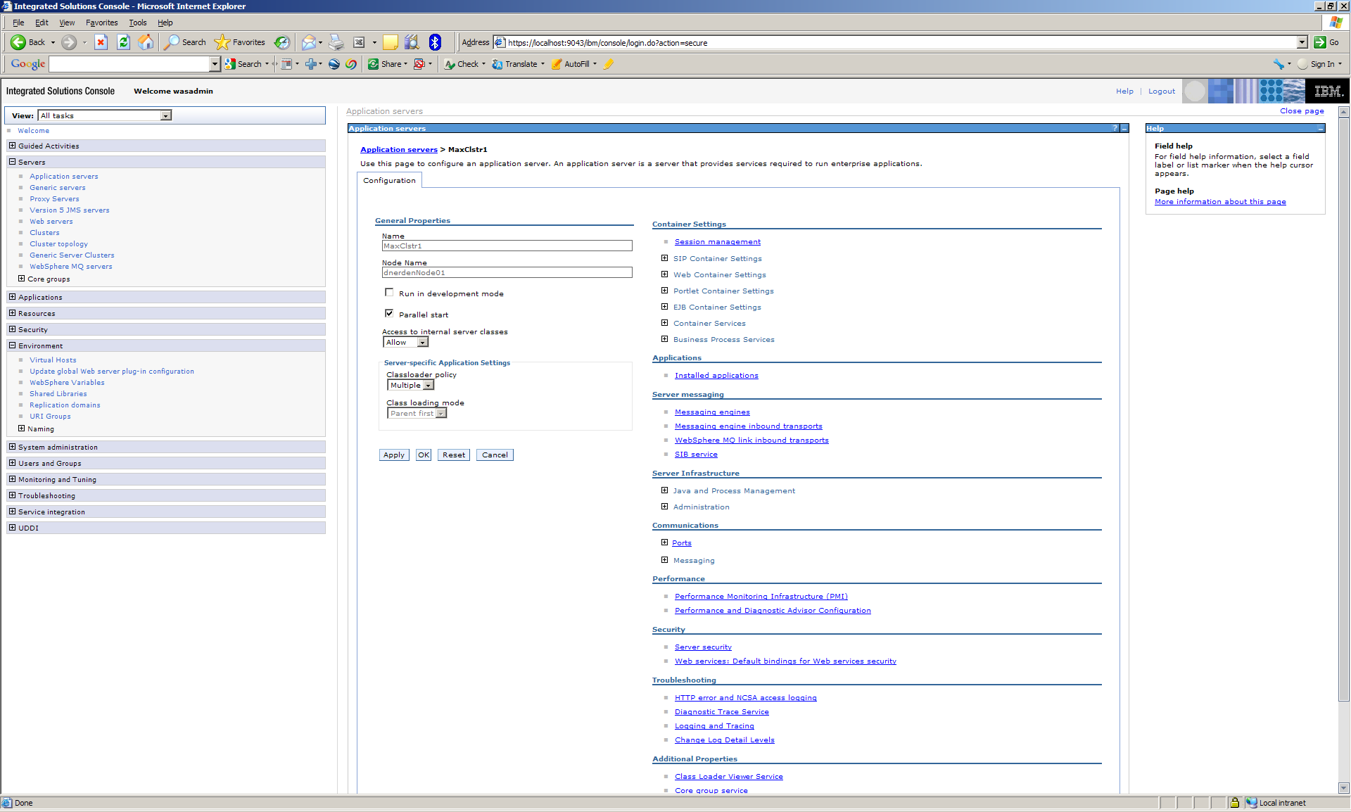
    - Under Communications expand Ports
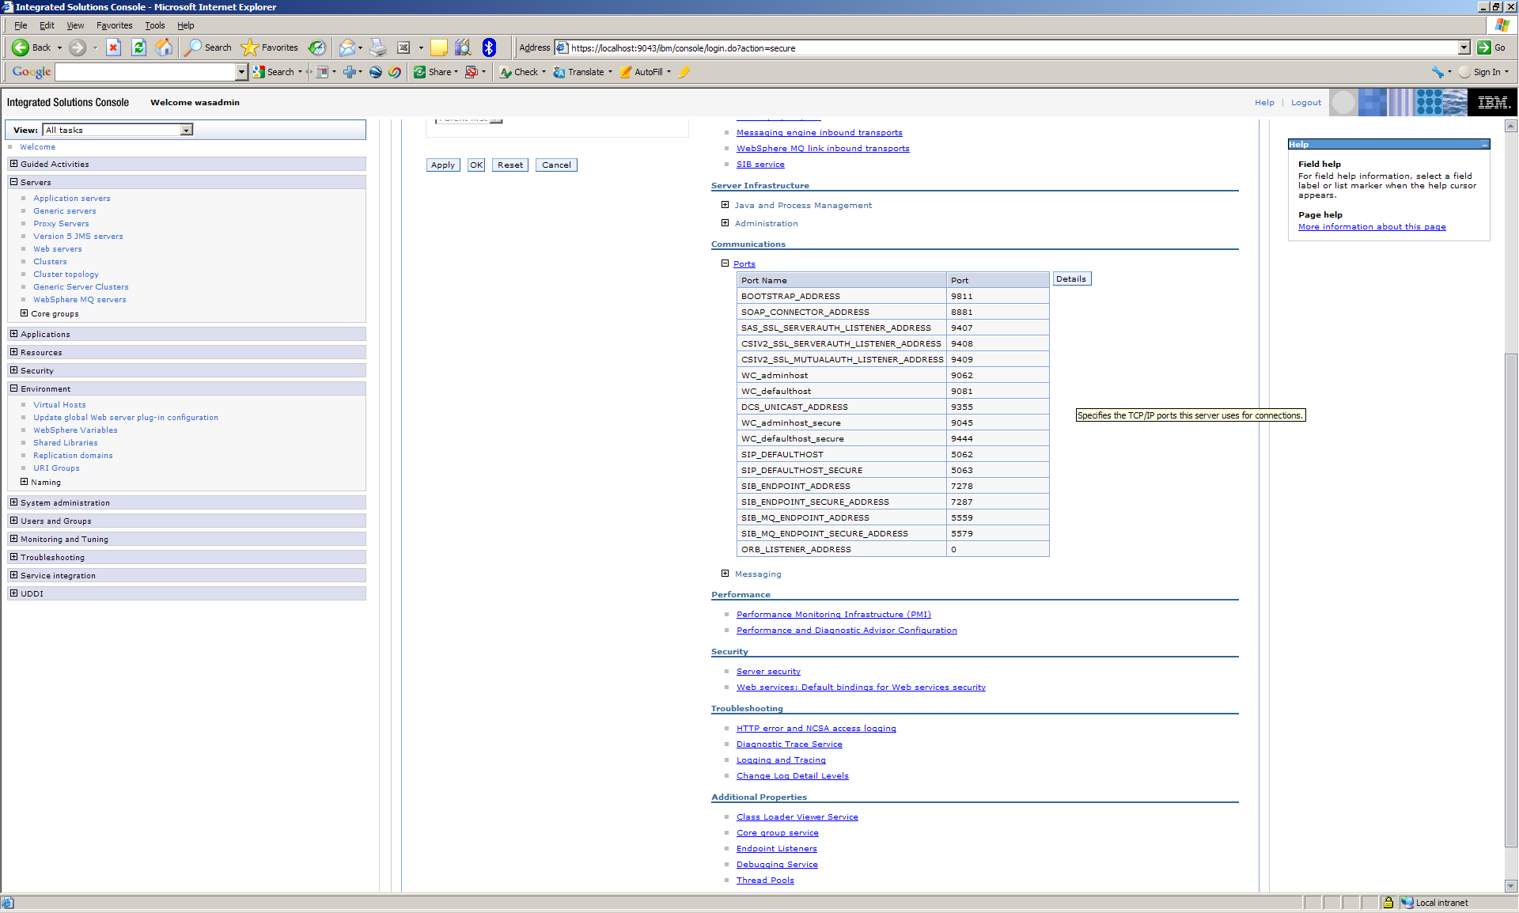
    - Note the Port for the WC_defaulthost Port Name (in this example 908)
    - Repeat the same for the other cluster member application servers

  - Expand Environment
  - Click Virtual Hosts

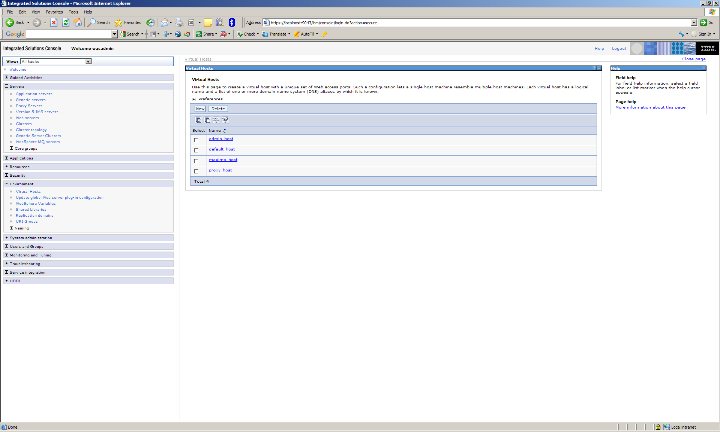

  - Click New
  - Enter Virtual Host name and click OK

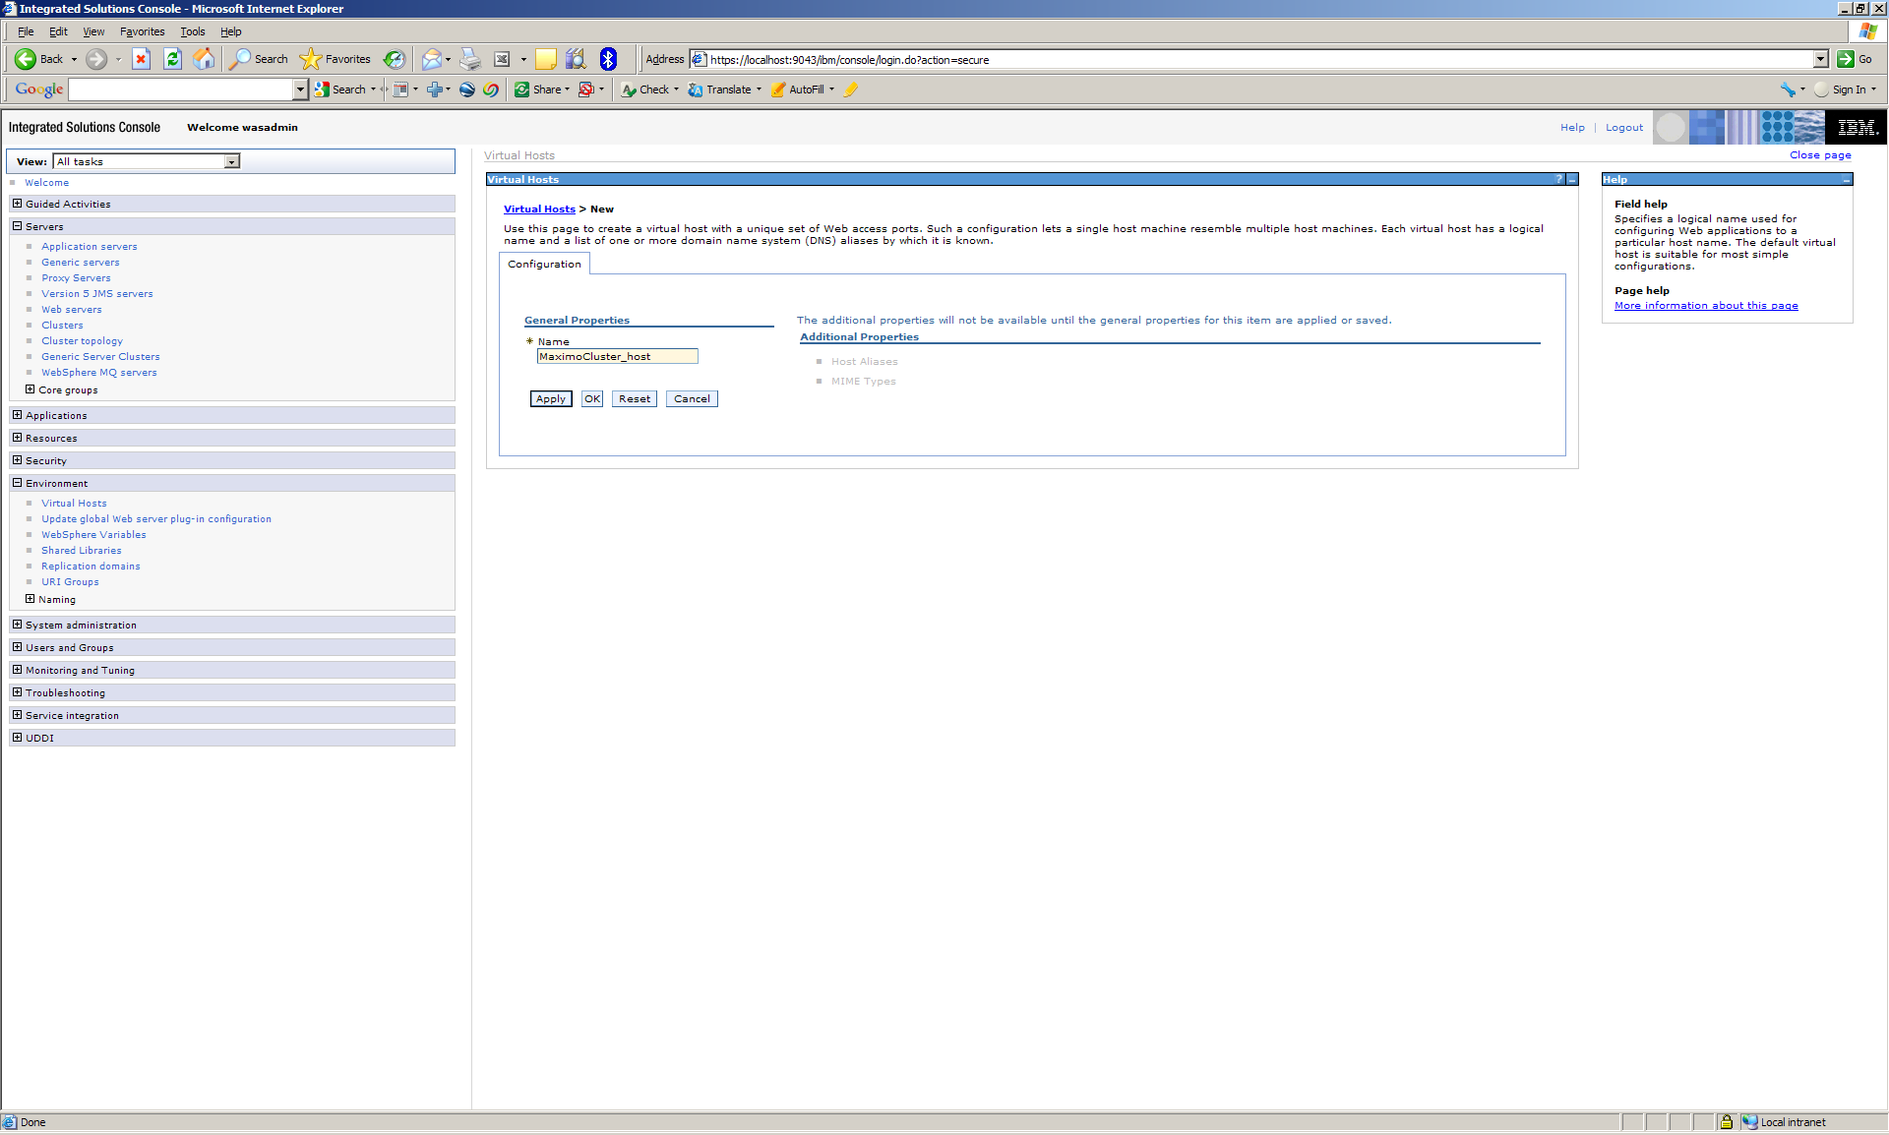

  - Click Save to save changes

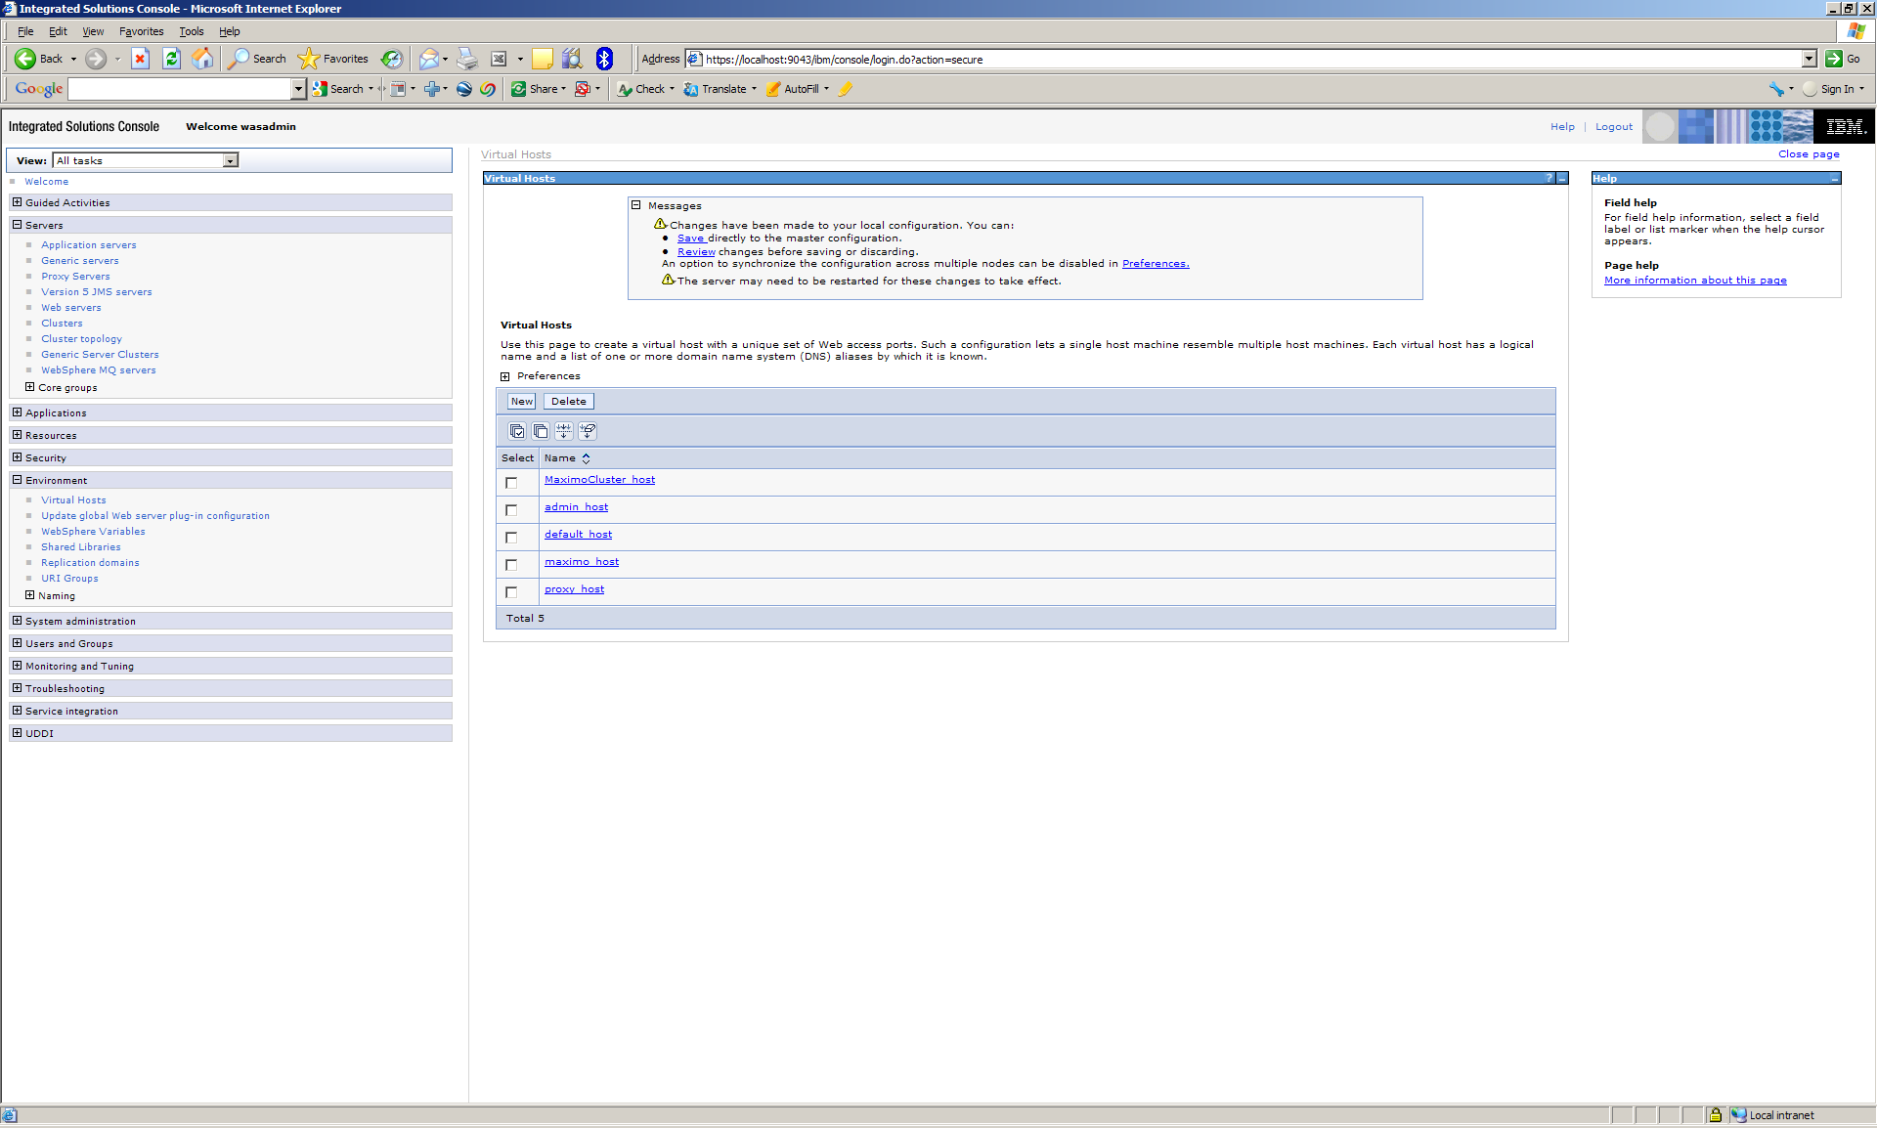

  - Click the Virtual Host just created

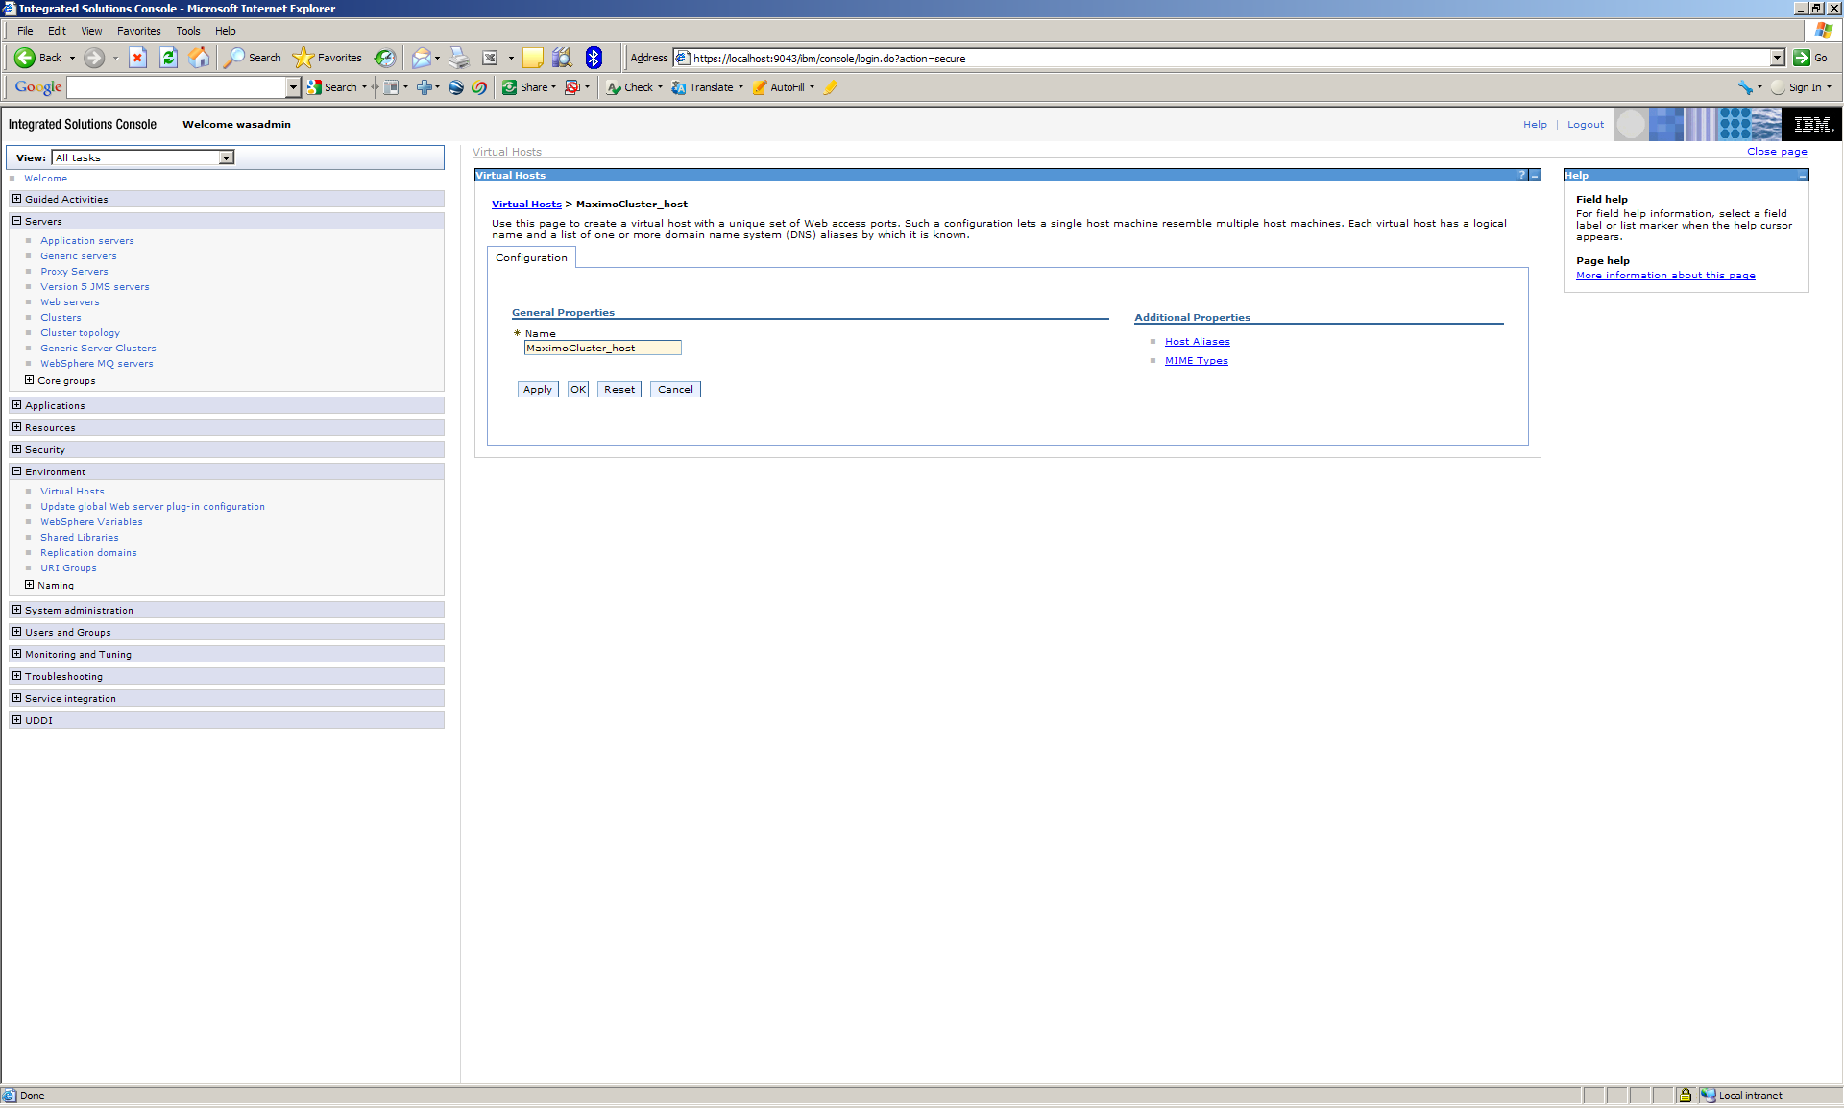

  - Click host aliases

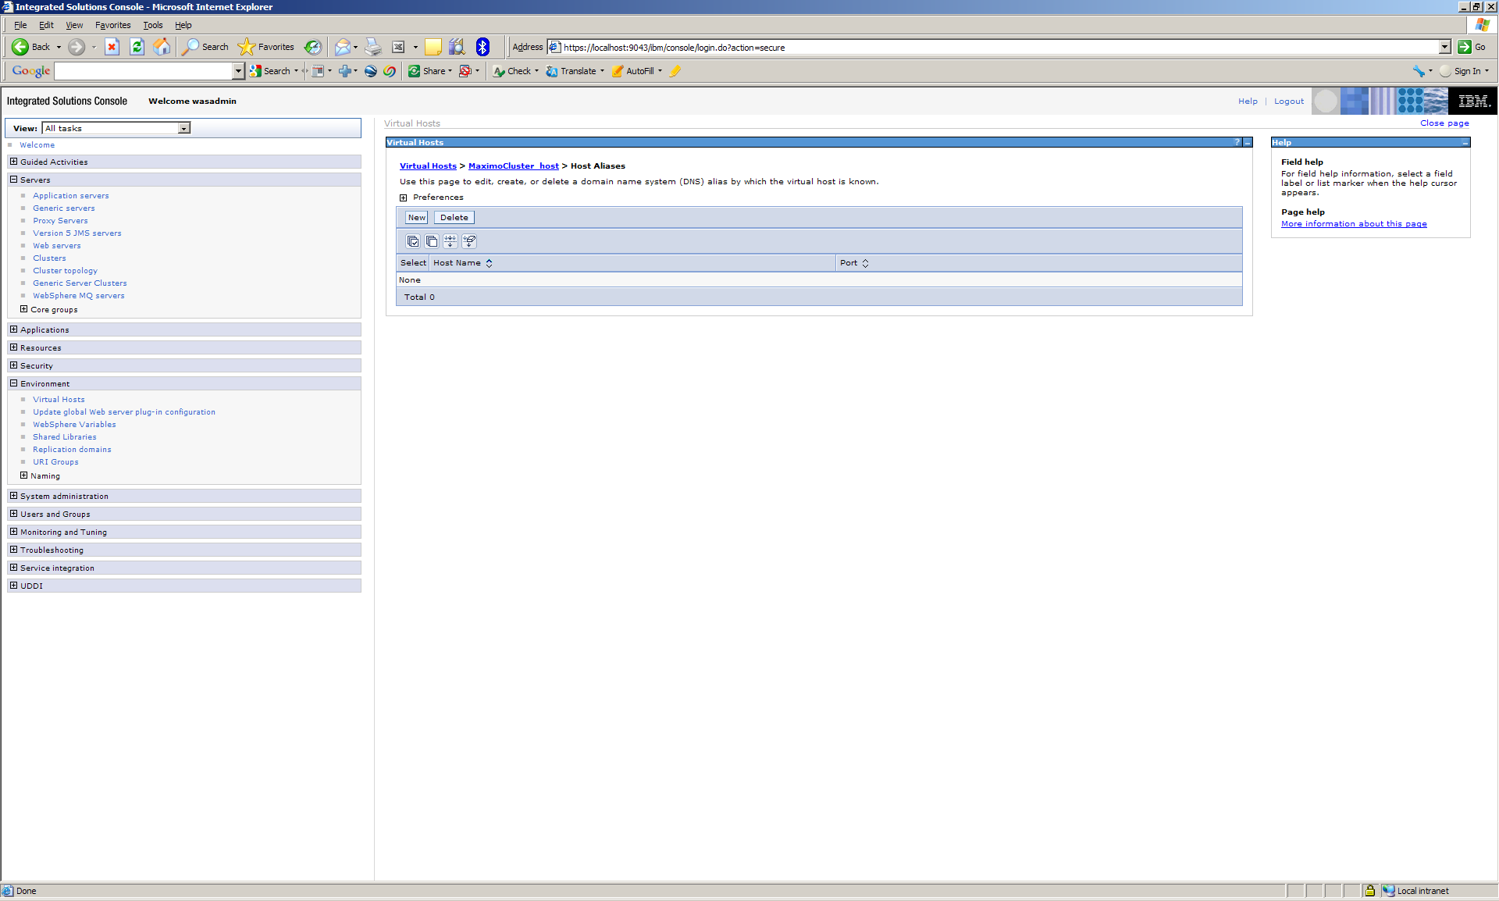

  - Click new

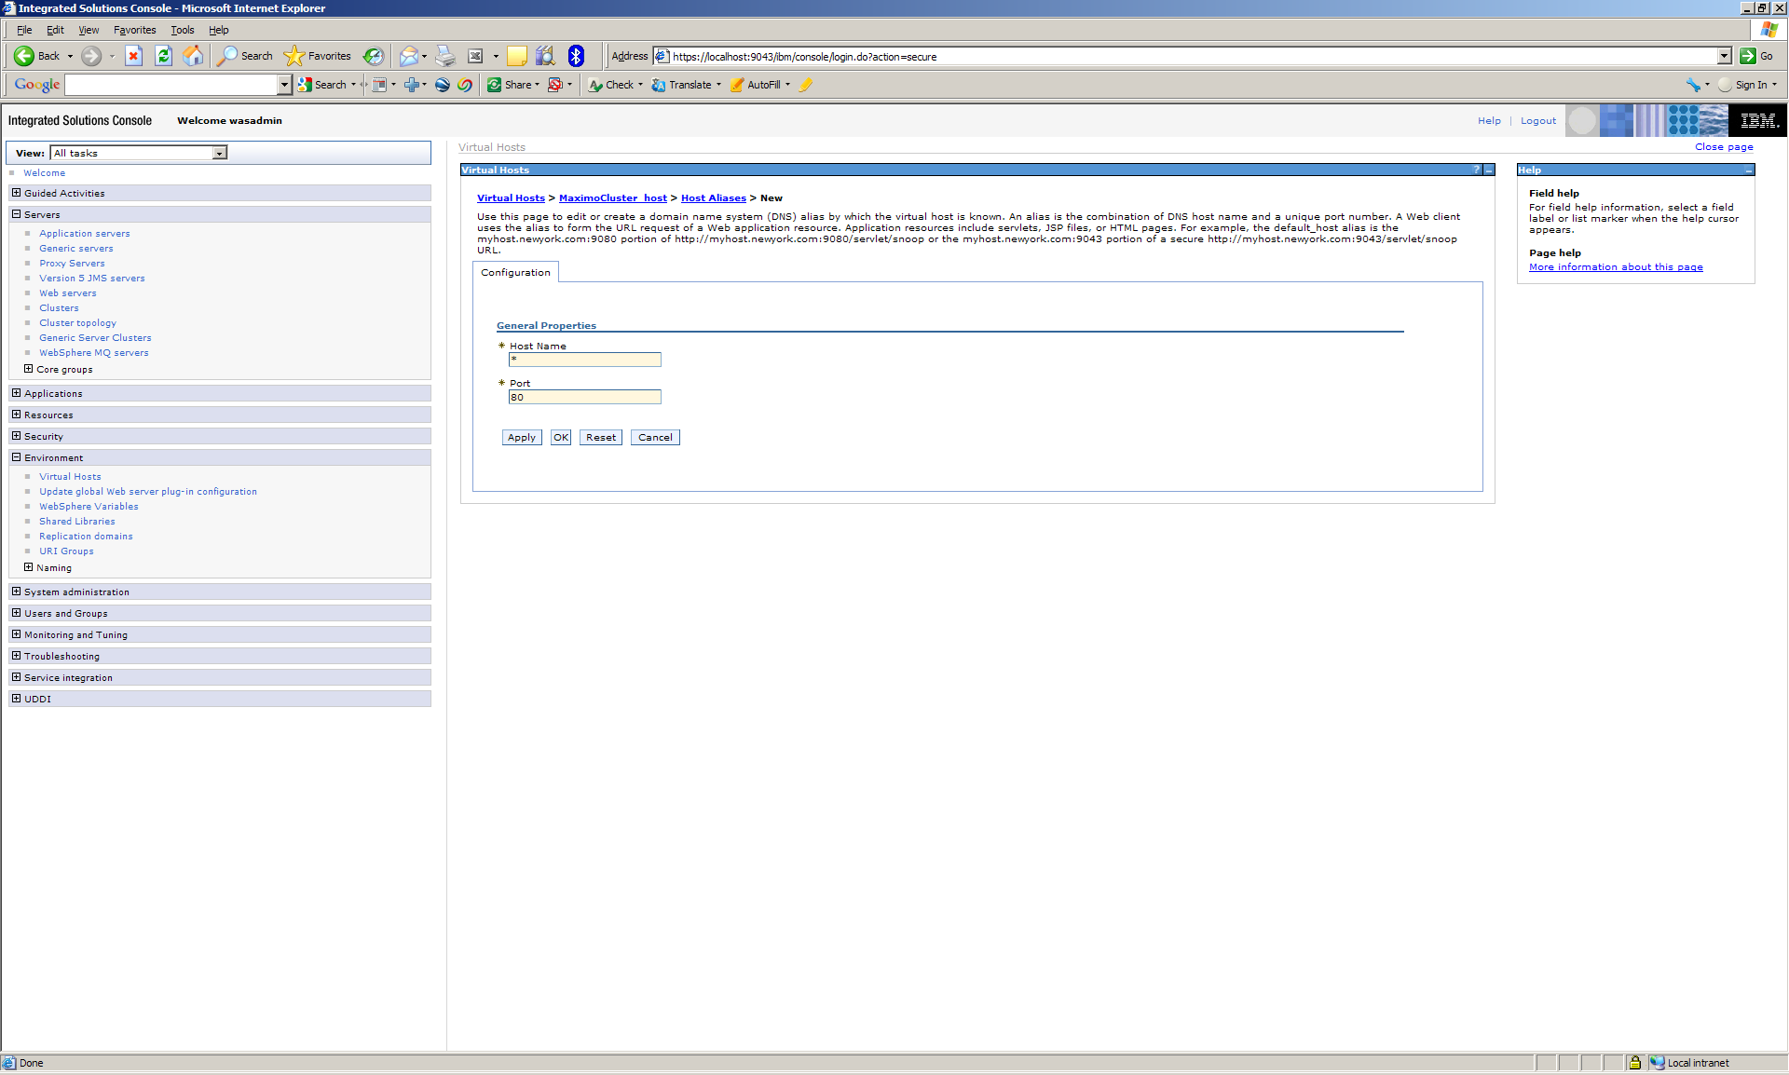

  - Enter the web server port (default 80) and leave host name as * and click OK
  - Click new and enter the port of the first cluster member (i.e. 9081) and leave host name as * and click OK
  - Repeat for each cluster member. When finished click Save

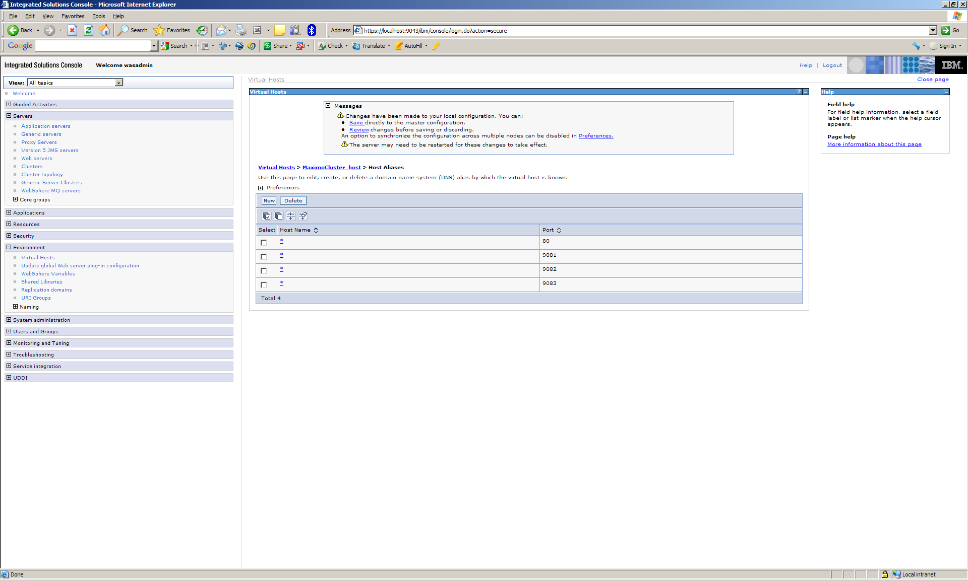

The cluster is now created. The Maximo and Maximo help EAR files can be deployed to the cluster.

- Deploy EAR files to the cluster
  - Expand Applications and click Enterprise Applications

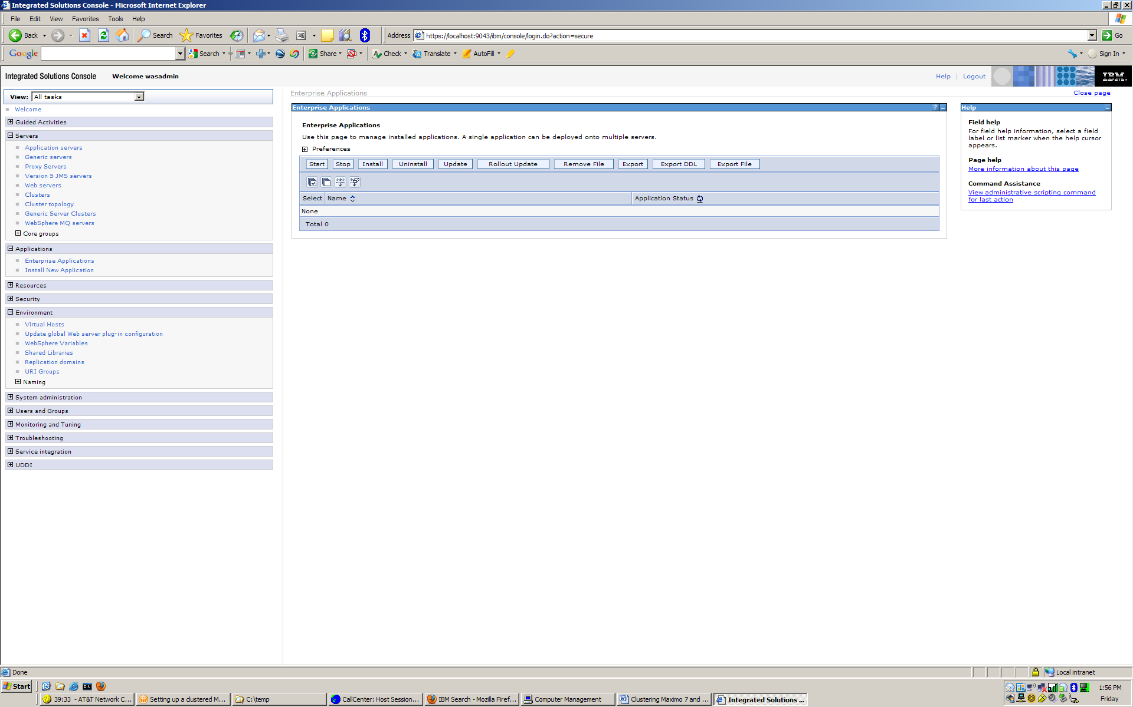

  - Click Install

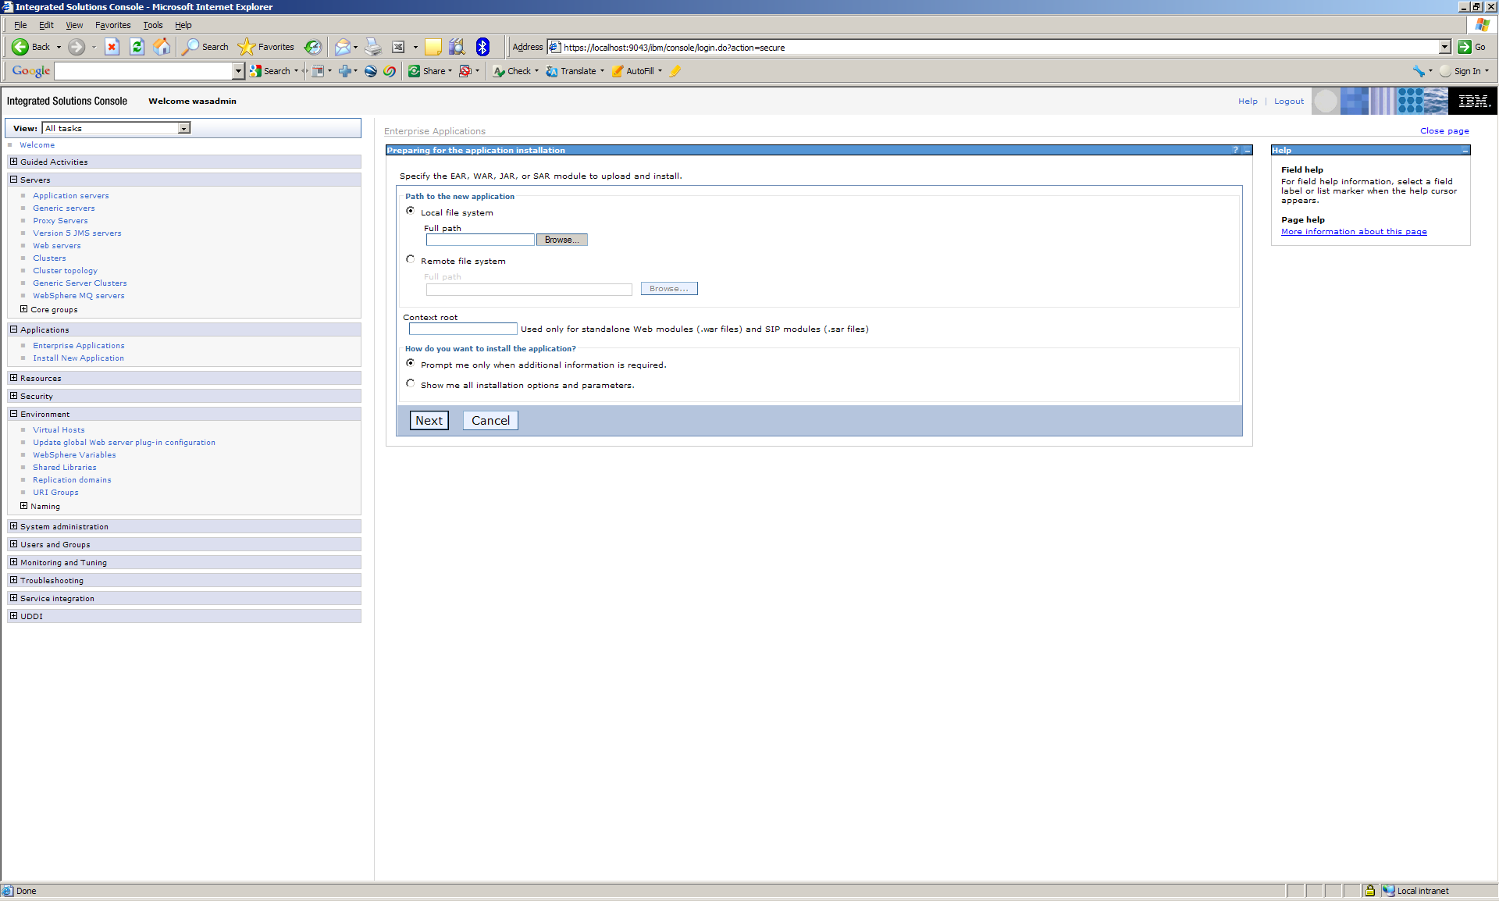

  - Browse to the maximo.ear file (ibm\smp\maximo\deployment\default) and click Next

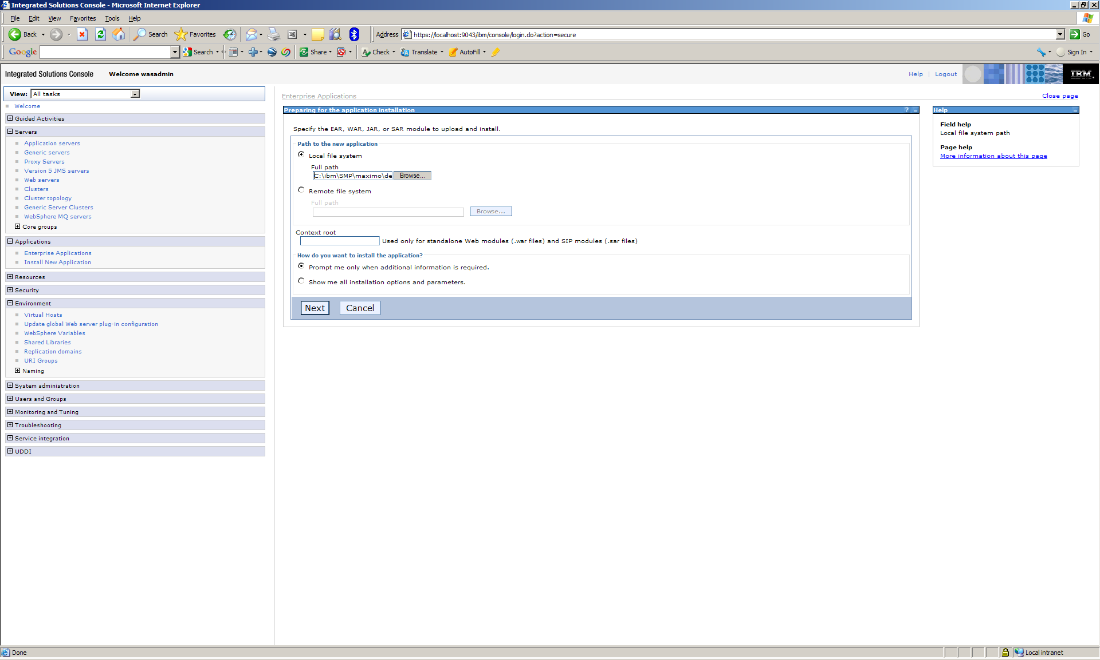

  - Accept the defaults and click Next (If you have the Maximo application deployed to the MXServer application server you will need to name this Maximo application something else. In the Application name field change Maximo to something else)

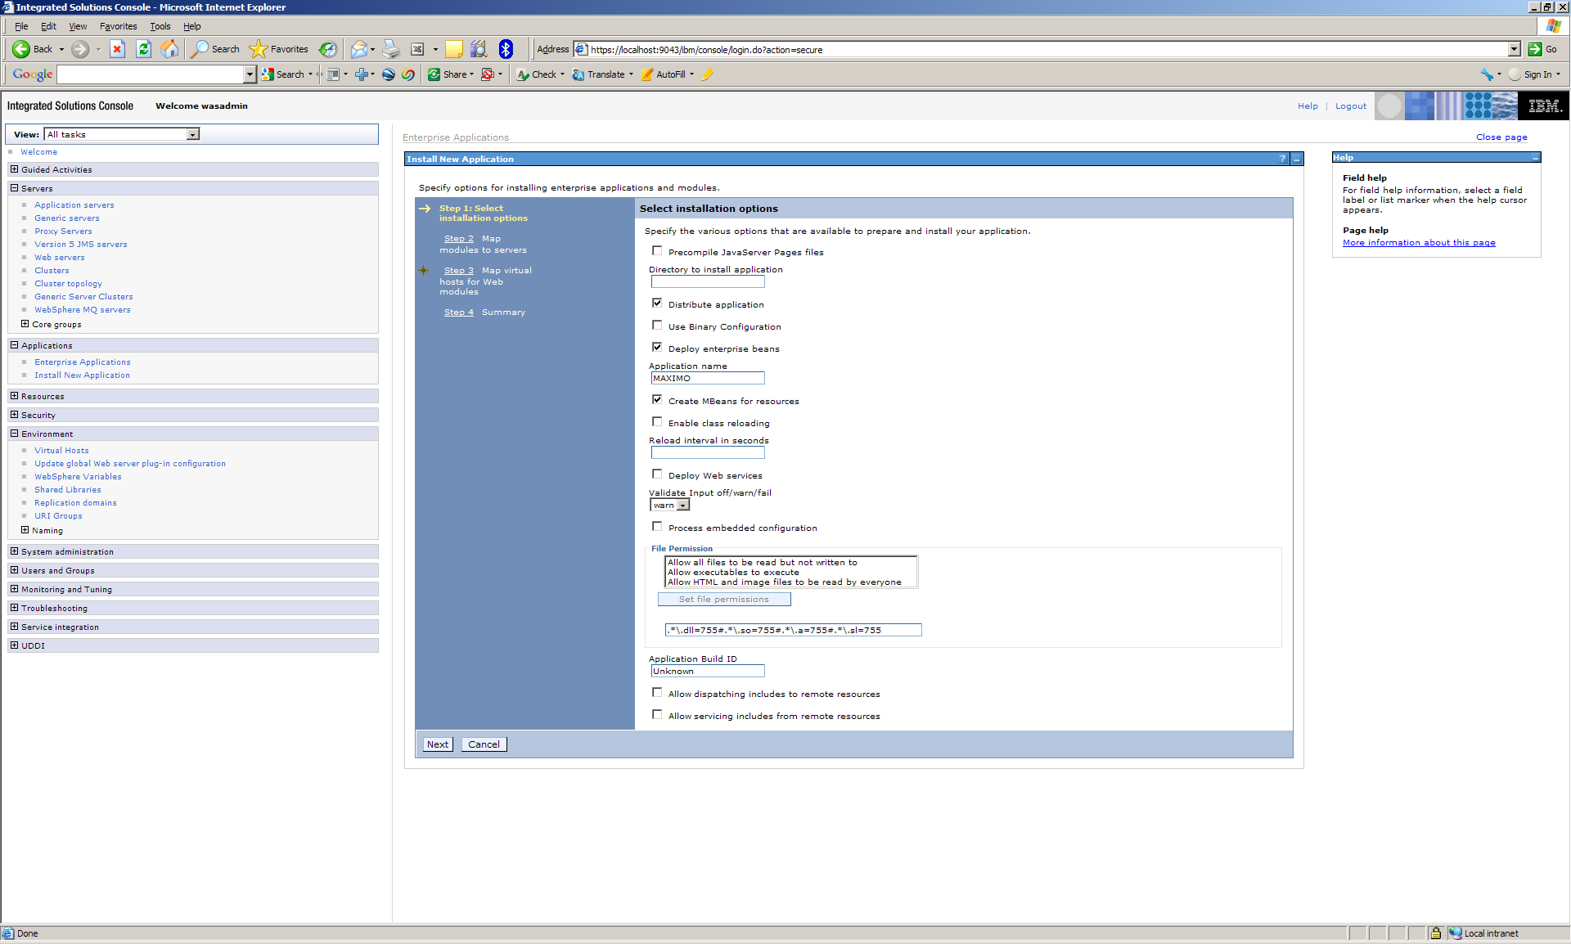

  - Select all the modules and select the Cluster and if you have a web server select that and click Apply. Then click Next.

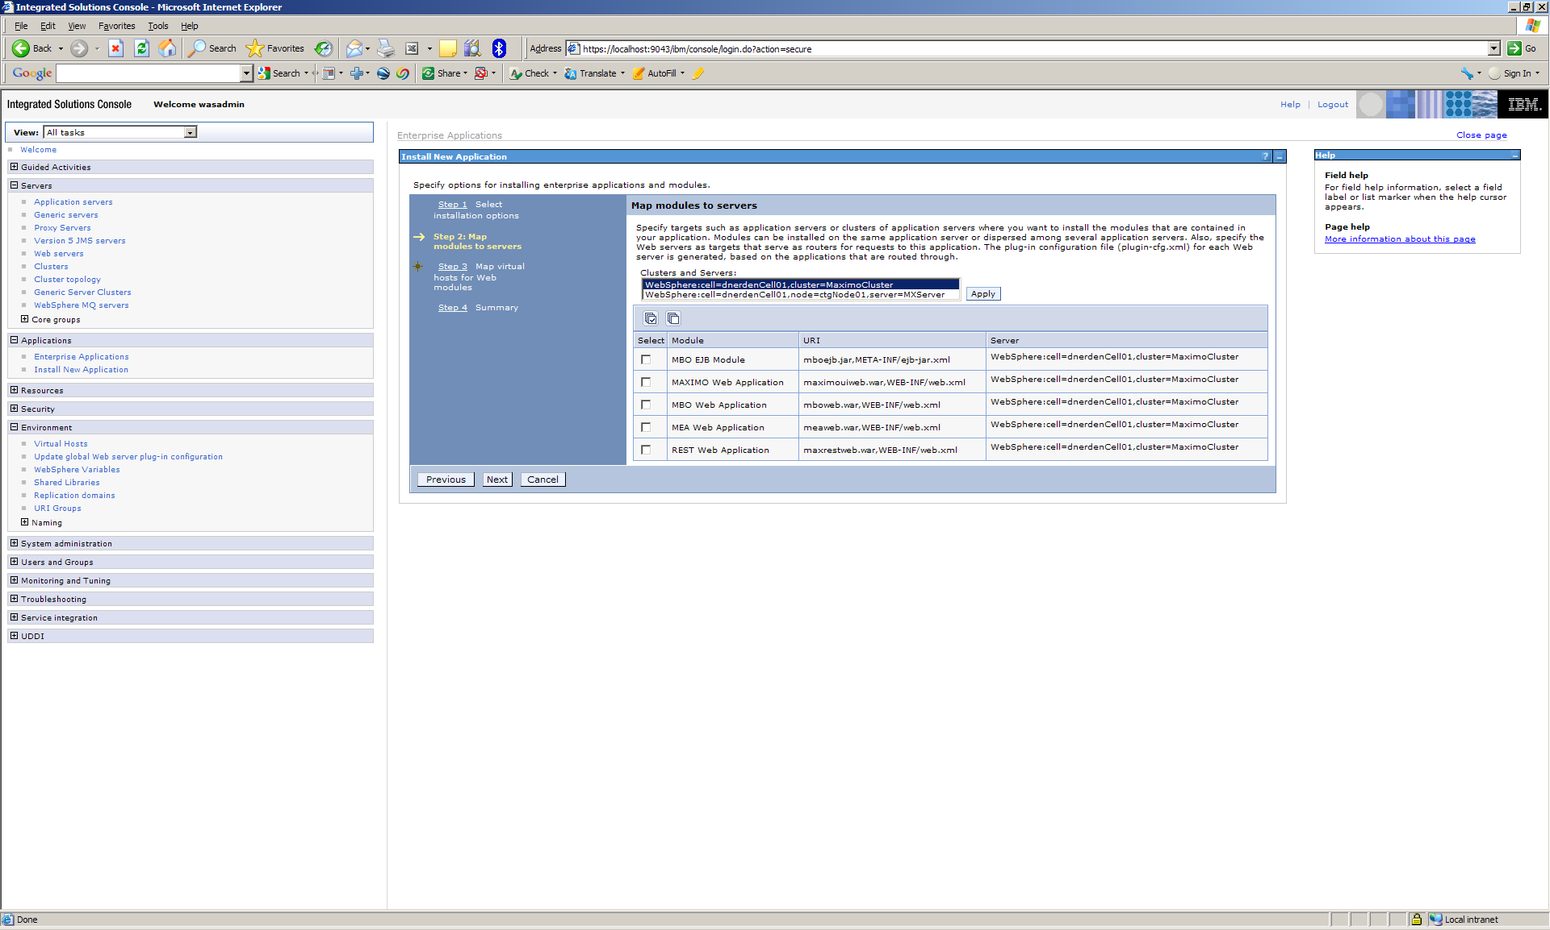

  - Select all the modules and select the cluster virtual host for all the modules and click Next.

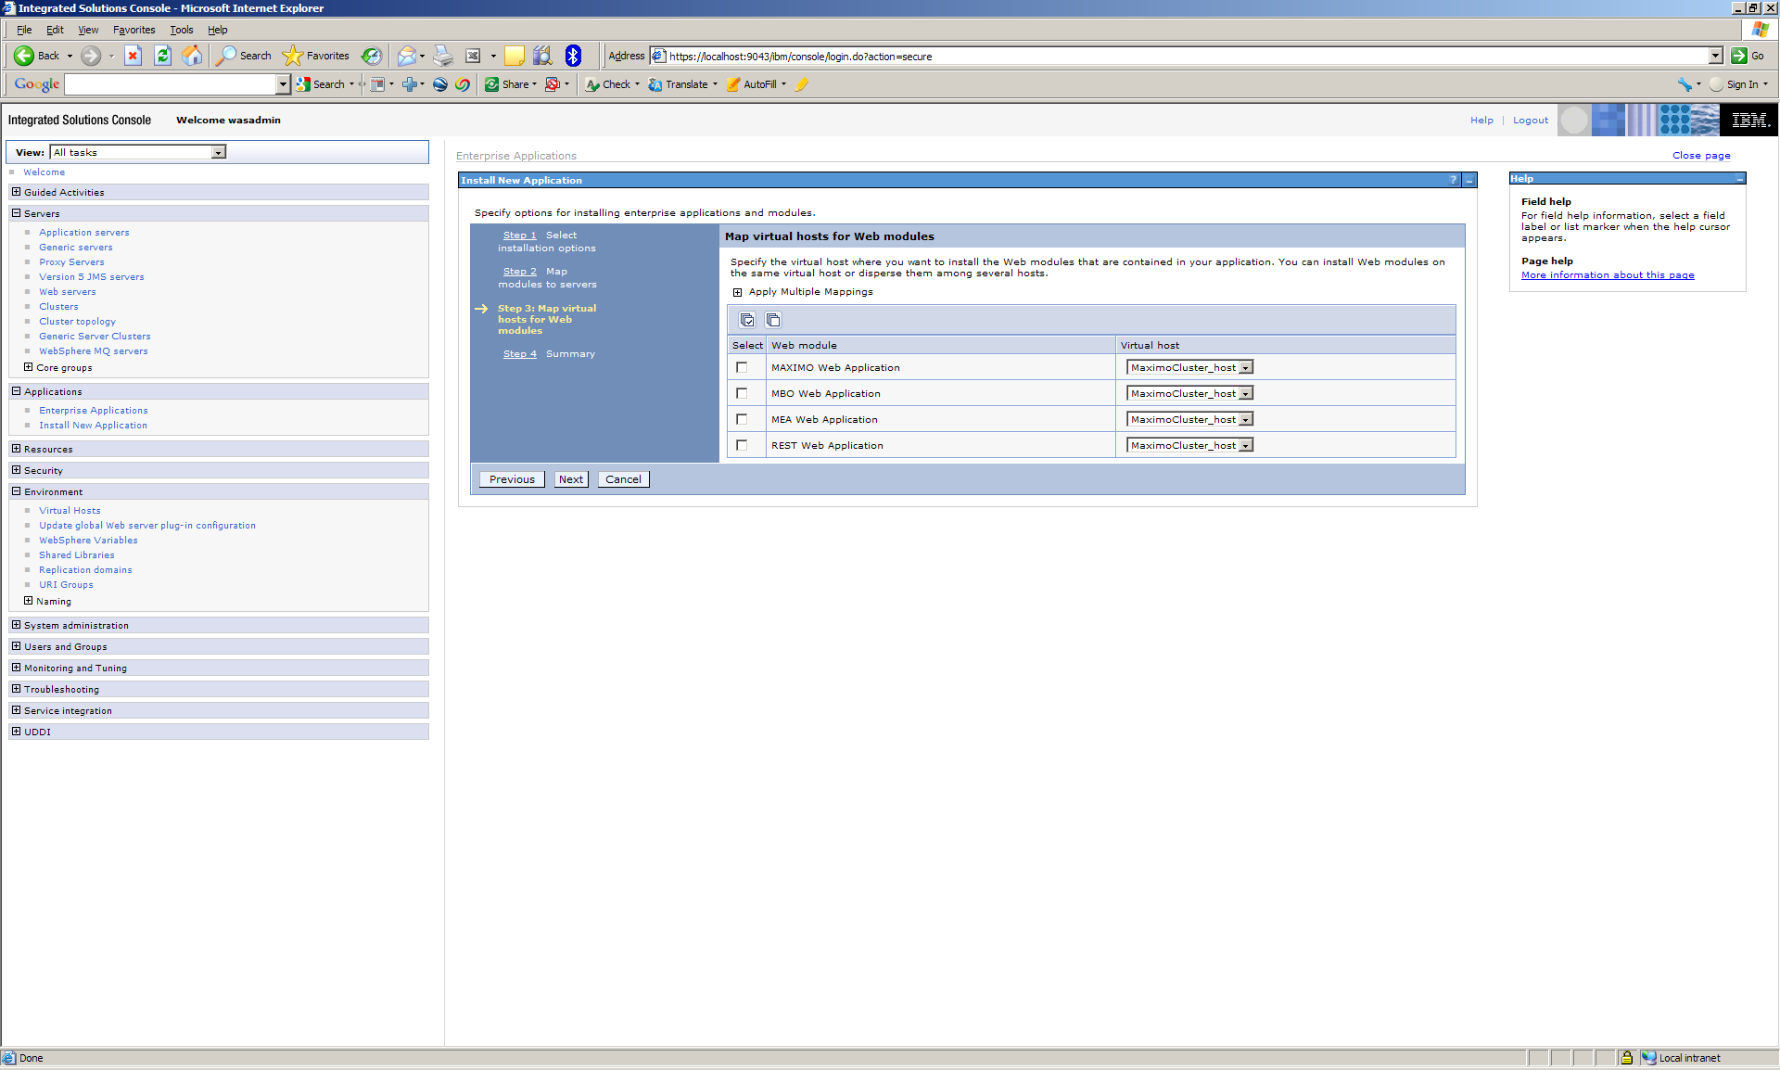

  - Click Finish

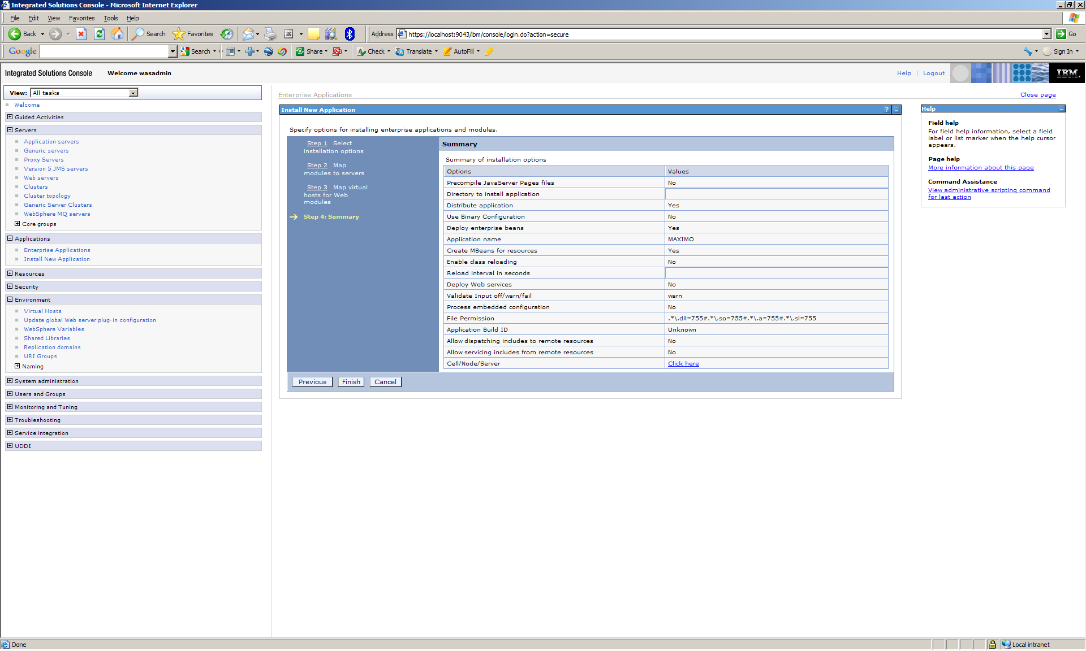

  - When the application has been deployed click Save

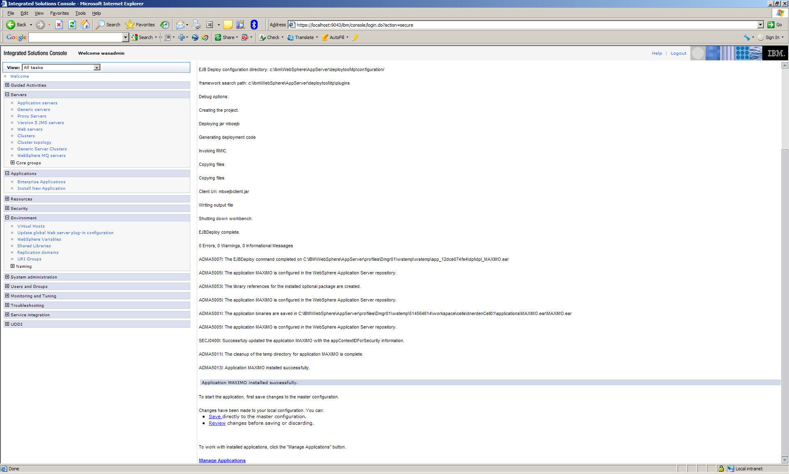

  - Repeat for the Maximo help EAR

- Start the Cluster
  - Expand Servers and click Clusters
  - Select the cluster and click Ripplestart. Each cluster member will be started

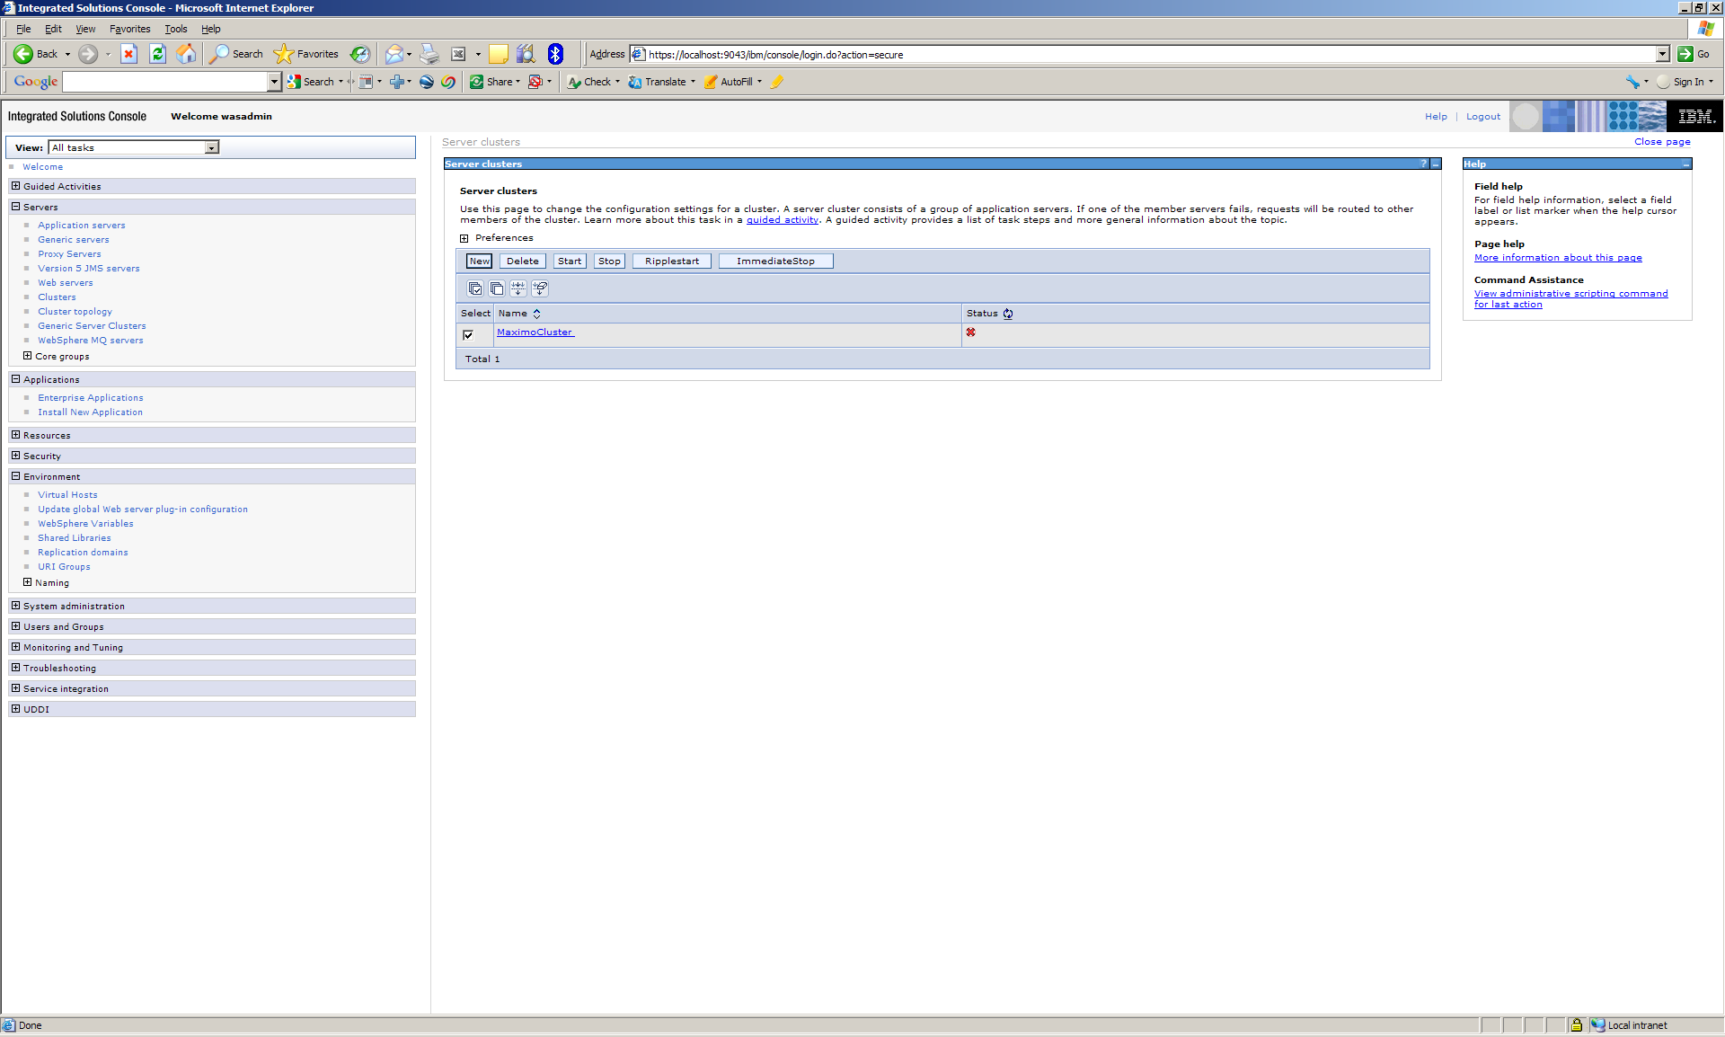

Notes

- When deploying more than 1 Maximo application server on a physical server create RMI as a separate application server.

  - Understanding the Maximo Implementation of Java Remote Method Invocation
https://www-304.ibm.com/support/docview.wss?uid=swg21262022

  - Deploying the RMI Registry (rmireg.war) in WebSphere for Windows
https://www-304.ibm.com/support/docview.wss?uid=swg21291015

- Other support documents regarding Maximo clustering

  - Setting up a WebSphere Cluster for use with Maximo 7 Integration Framework
https://www-304.ibm.com/support/docview.wss?uid=swg21330565

  - Building different maximo.ear files from one Maximo installation folder
https://www-304.ibm.com/support/docview.wss?uid=swg21450028

  - Take Control of JVM Names for Instance, Cron and Log Names Using -Dmxe.name
https://www-304.ibm.com/support/docview.wss?uid=swg21446387

