Clustering Maximo 7.1.x with Oracle WebLogic 9.2

Multiple Application Servers can be created to cluster like functionality in Maximo. For example a group of Maximo Servers for the UI, a group for cron task, a group for integration, etc. A Maximo EAR file is deployed to the cluster and each cluster member runs that application. Each Application Server points to the same Maximo database. These Application Servers can be created on the same physical server as well as different physical servers.

There are a number of hardware and software solutions for load balancing. This guide does not cover load balancing it goes through the process of creating a cluster. To distribute the user sessions to the members of the cluster you need to implement a load balancer.

Paths and file names used in the document are defaults from the WebLogic installation and Maximo installation released February 2010 or later. This guide assumes the Maximo installation has occurred by following the Maximo installation guide.

Configuration

This configuration will include three Maximo Application Servers configured on the same physical server. The example cluster created will be a UI cluster. Maximo properties will be set differently for clusters for other functions (i.e. cron, integration, etc.)

- Modify the maximo.properties and add the property to not run the cron tasks
  - Rename the ibm\smp\maximo\applications\maximo\properties\maximo.properties file
  - Copy the ibm\smp\etc\maximo.properties_orig file to ibm\smp\maximo\applications\maximo\properties\maximo.properties
  - Edit the maximo.properties file and add the following line
mxe.crontask.donotrun=ALL
  - Verify the other properties values are correct
  - Encrypt the properties file
    - From a command prompt change to the ibm\smp\maximo\tools\maximo folder
    - Run encryptproperties
- Build the Maximo EAR file
  - From a command prompt change to the ibm\smp\maximo\deployment folder
  - Create the EAR file, run buildmaximoear

- Start the Maximo Server created during the Maximo installation
  - From a command prompt change to the bea\user_projects\domains\base_domain
  - Run startweblogic
- Log into the WebLogic Administration Console
  - http://<servername>:7001/console
  - login with administrative user
- Click Lock & Edit

- Uninstall the Maximo Application from the Admin Server
  - Click Deployments
  - Select Maximo and click Delete

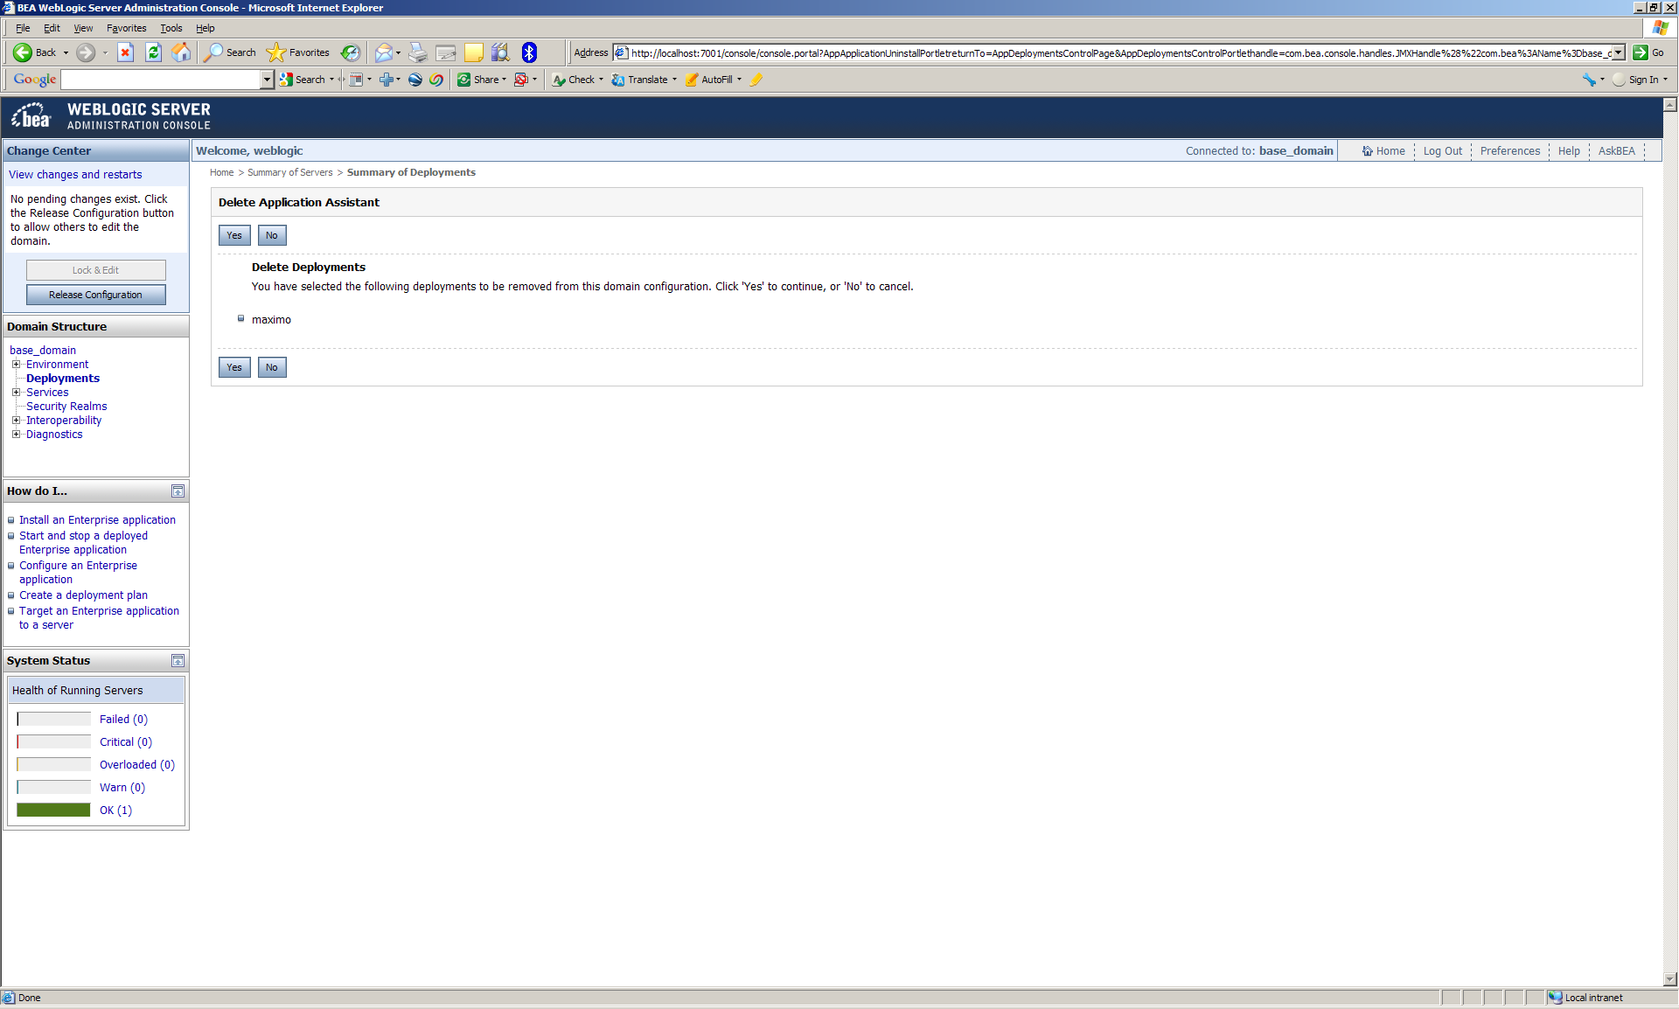

  - Click Yes
  - Click Activate Changes

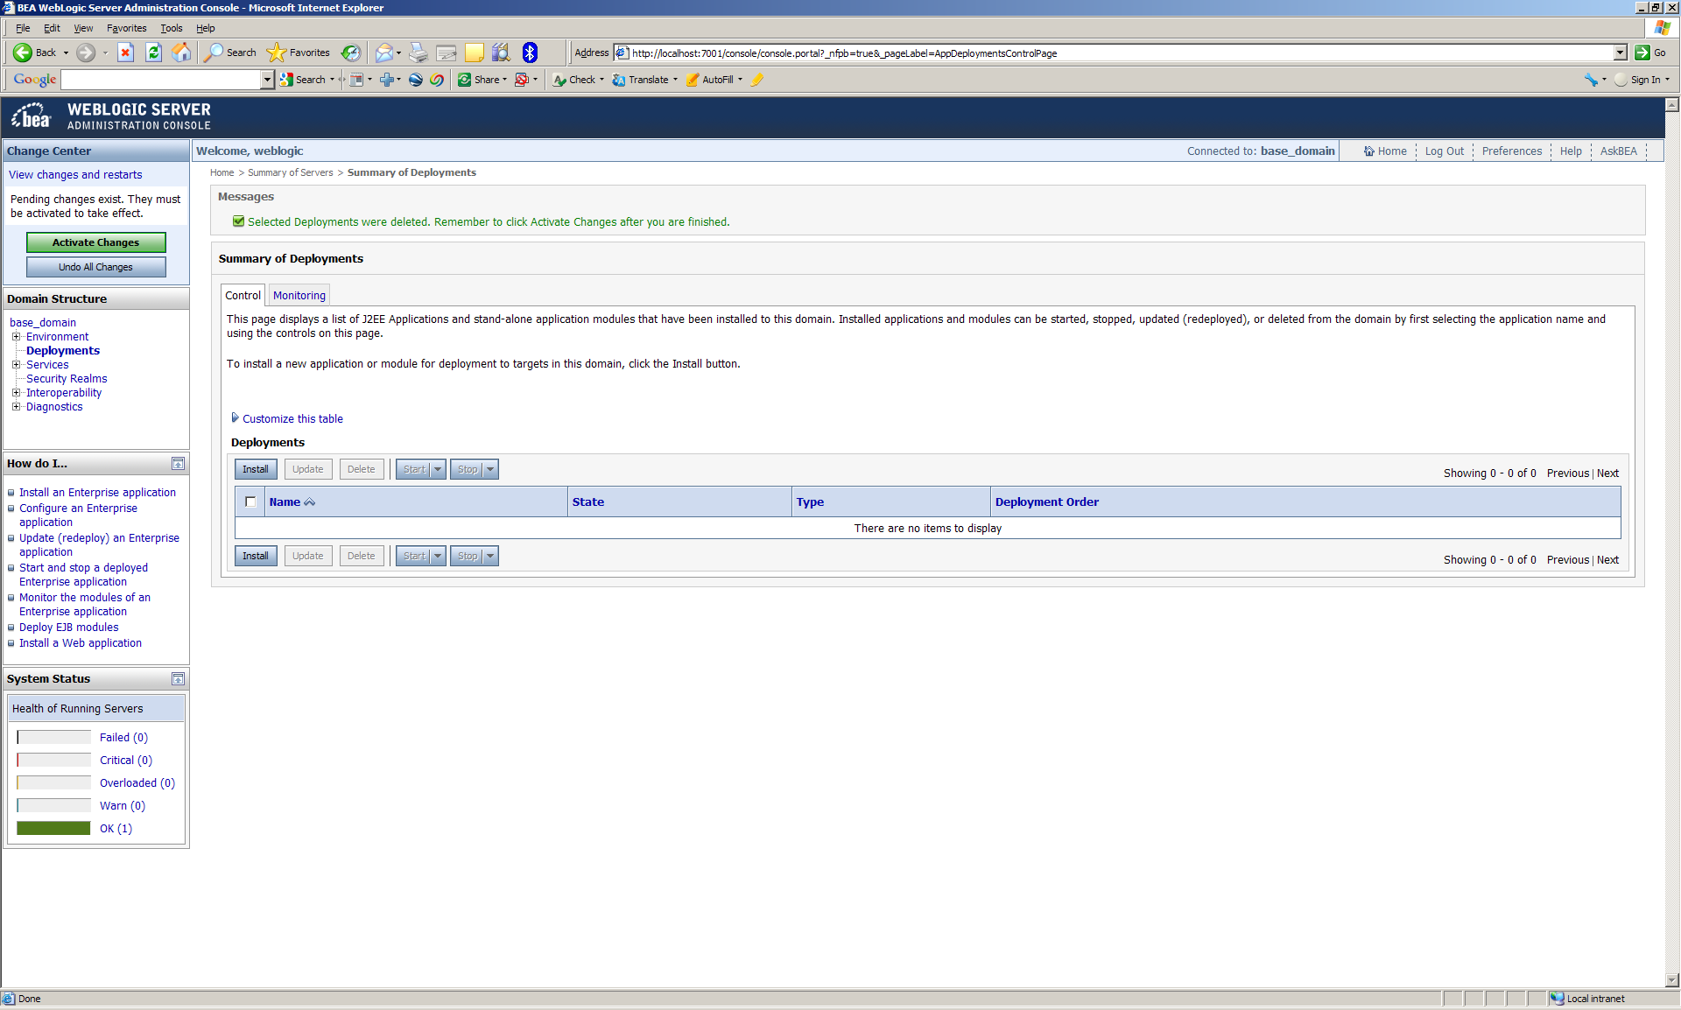

  - Click Lock & Edit

- Create the cluster
  - Expand Environment and click Clusters
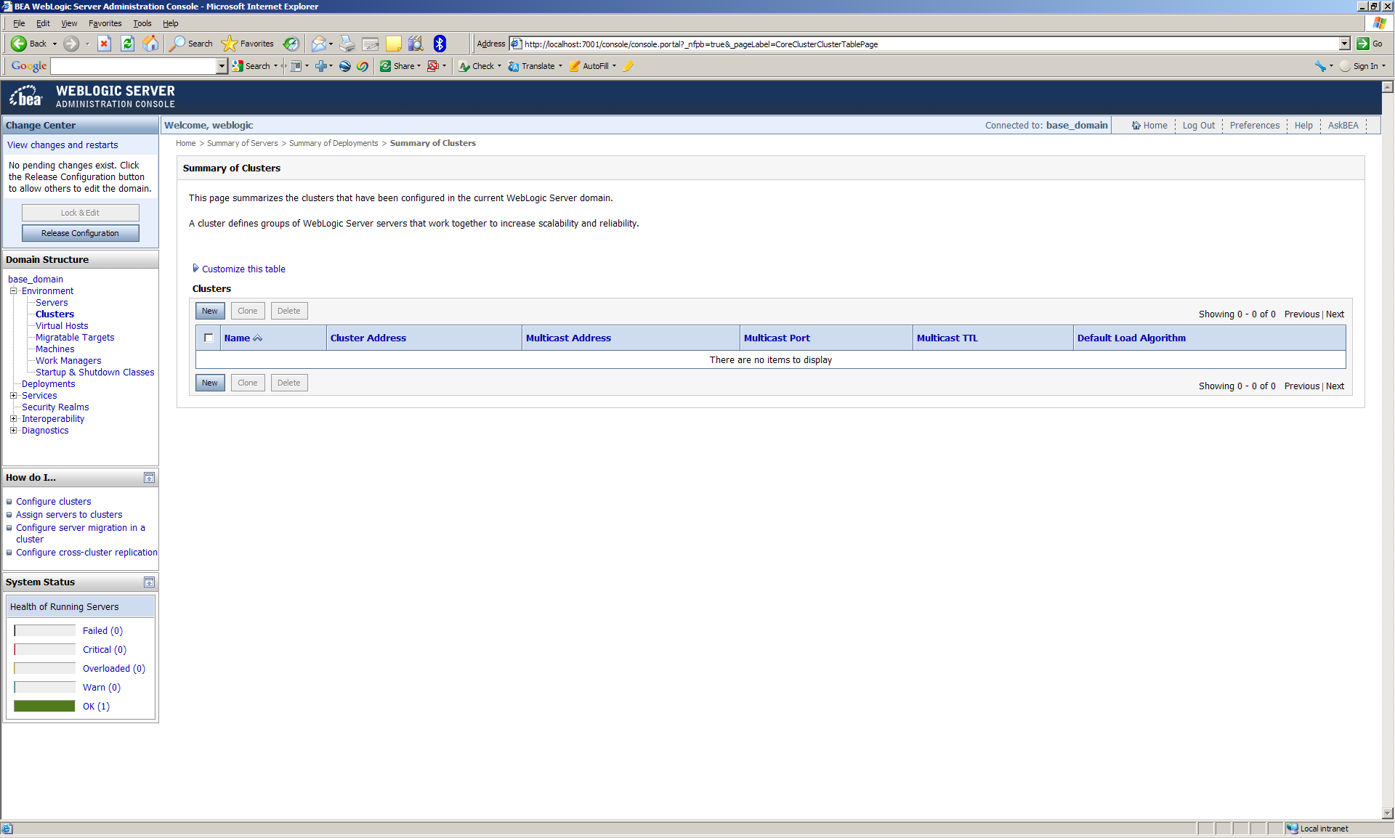

  - Click New
  - Name the cluster and click OK

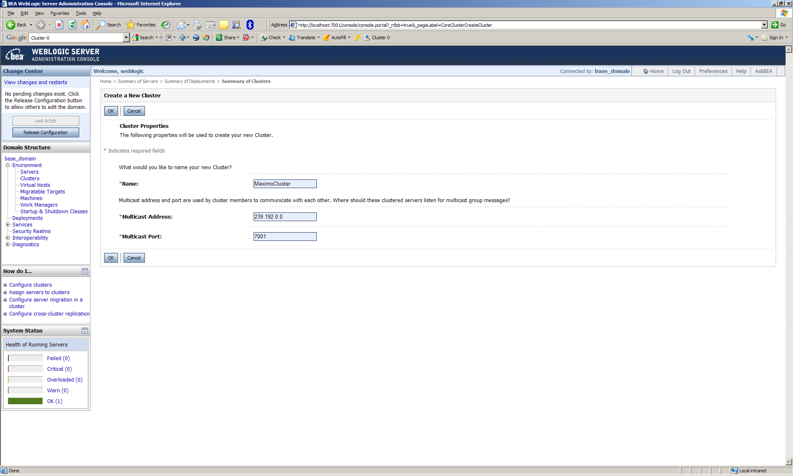

  - Select the cluster

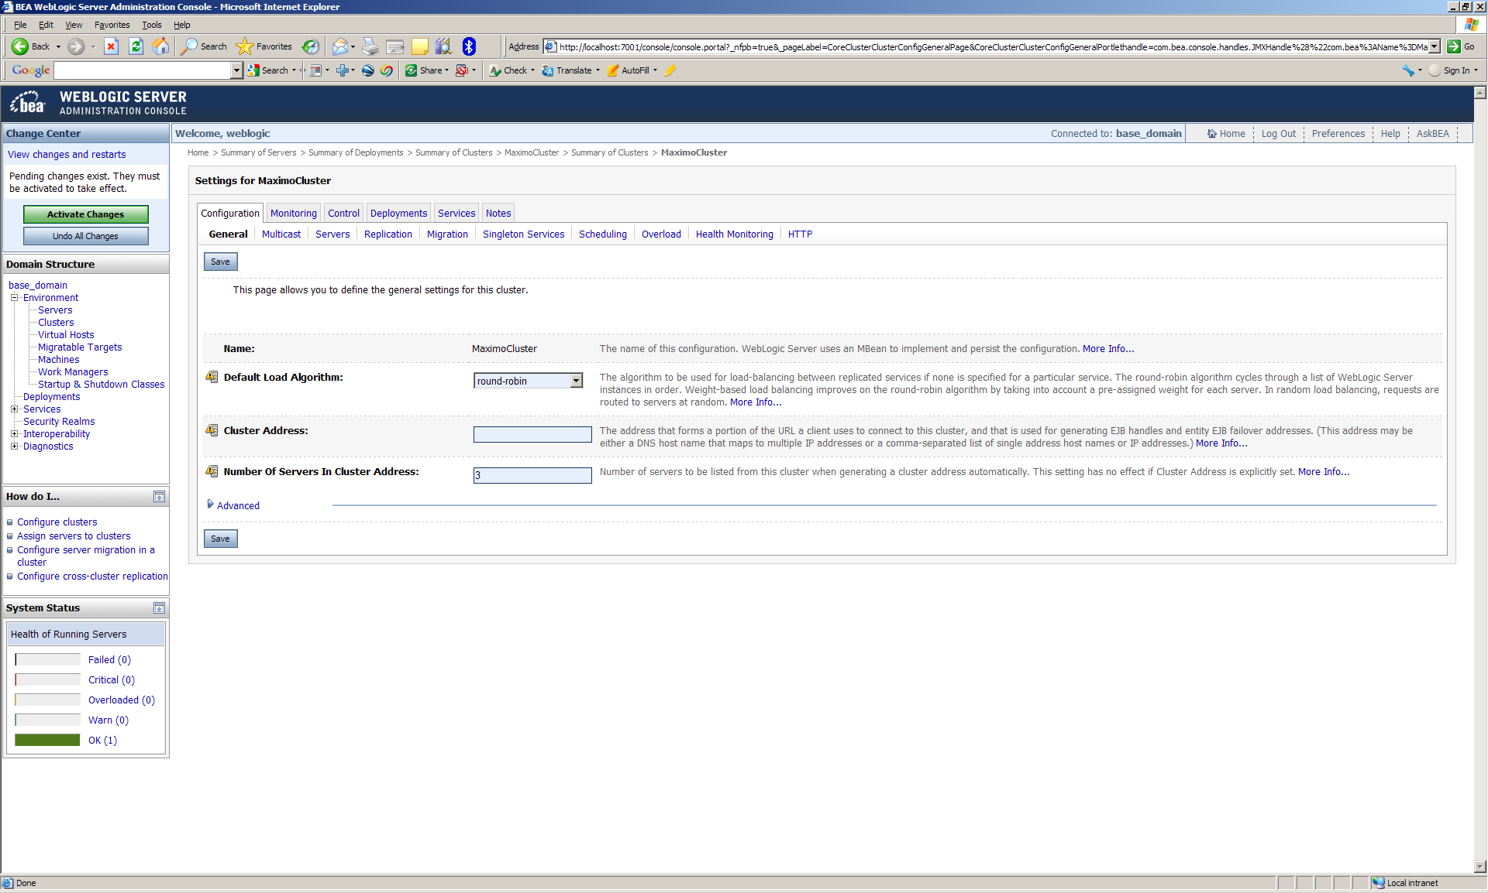

  - Click the Servers tab

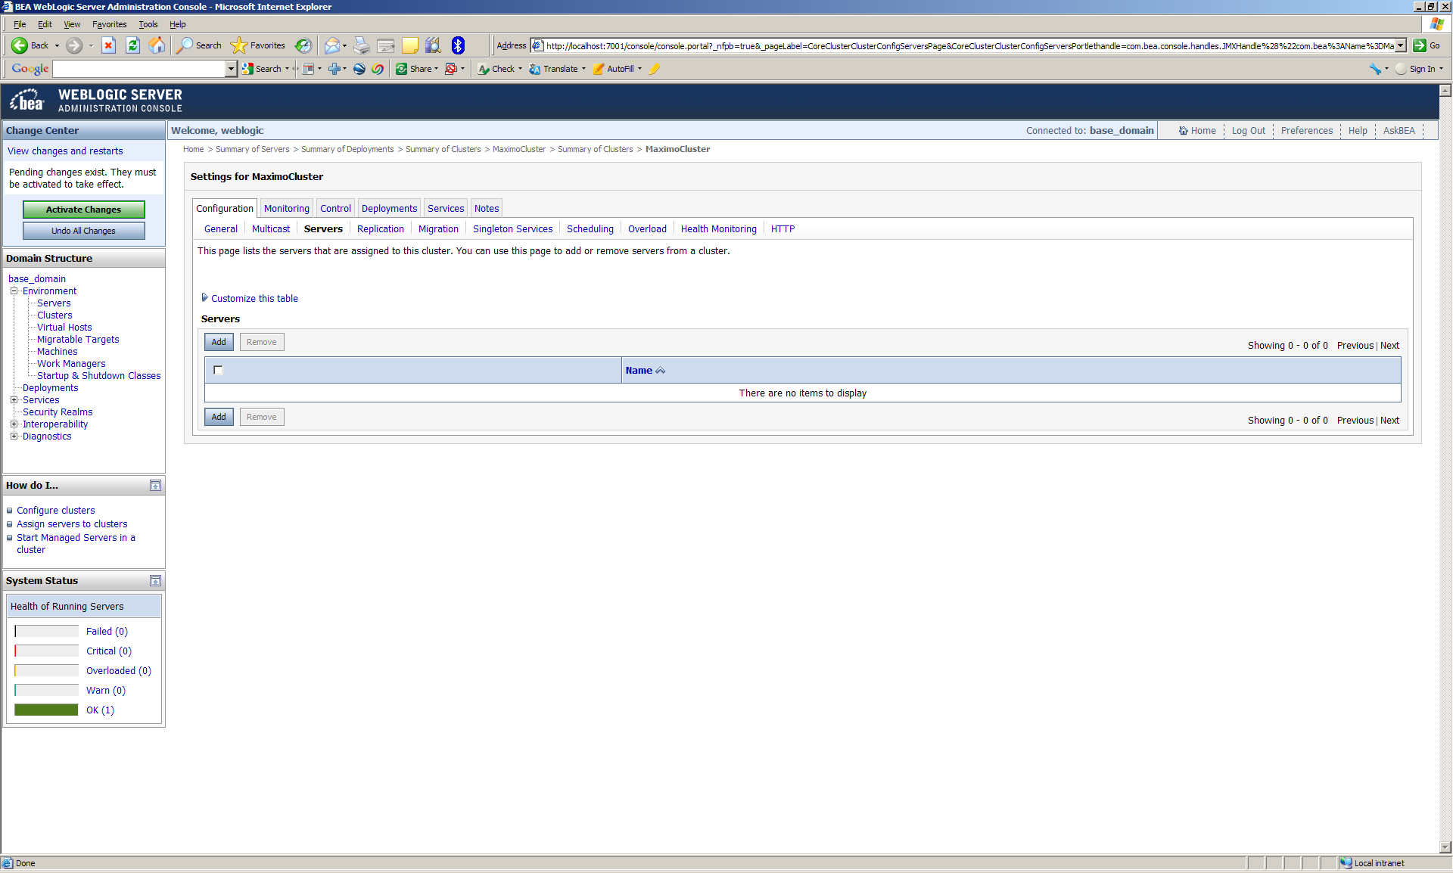

  - Click Add and select Create a new server and add it to this cluster and click Next

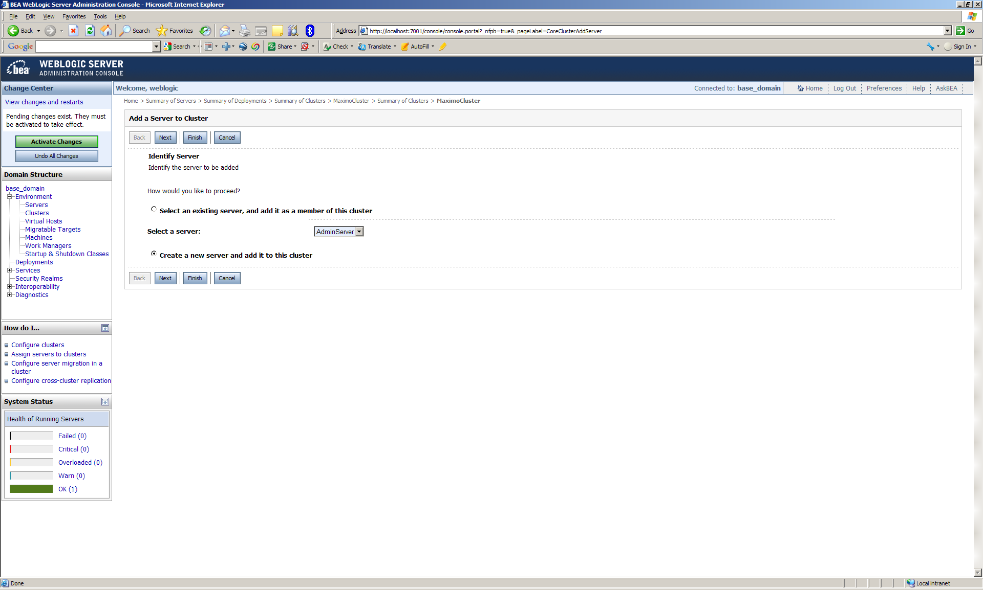

  - Enter the name of the first cluster member, the server this Maximo Server will be running and assign a port. All ports must be unique. Click Finish

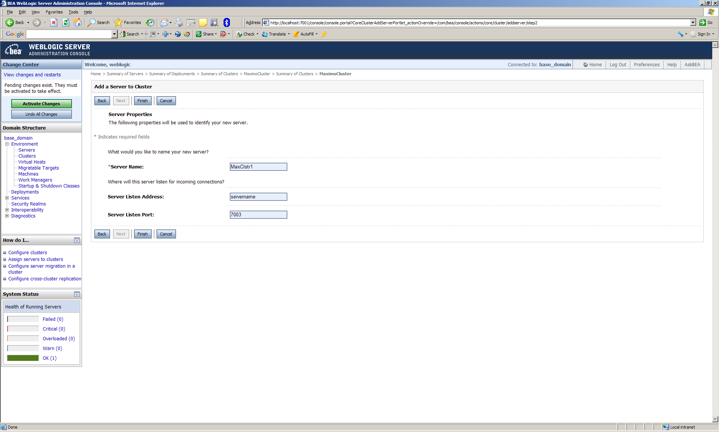

  - Repeat for each cluster member. Assign a unique port to each.

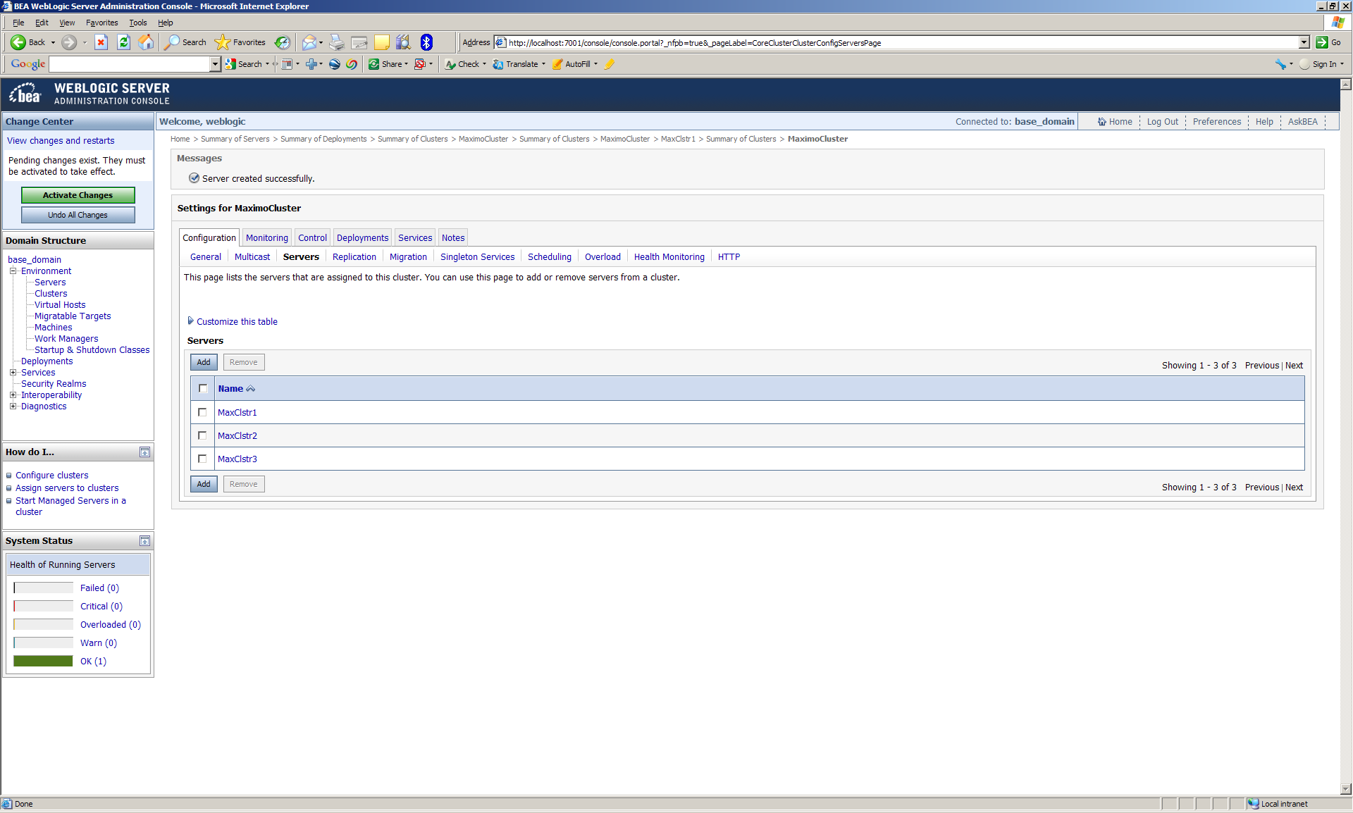

  - Click Activate Changes

The cluster is now created. The Maximo and Maximo help EAR files can be deployed to the cluster.

- Deploy EAR files to the cluster
  - Click Lock & Edit
  - Click Deployments and click Install

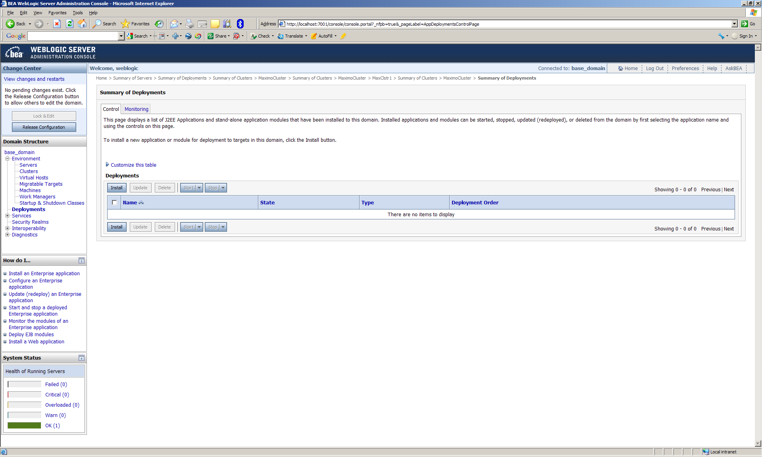

  - Click to the maximo..ear file (ibm\smp\maximo\deployment\default). Select the maximo.ear and click Next

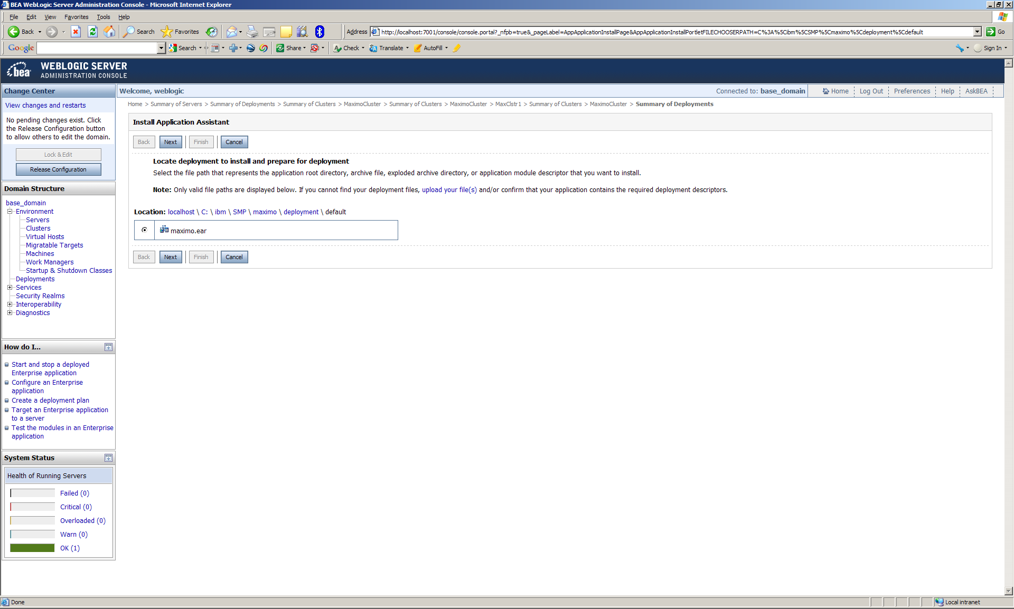

  - Accept the defaults and click Next

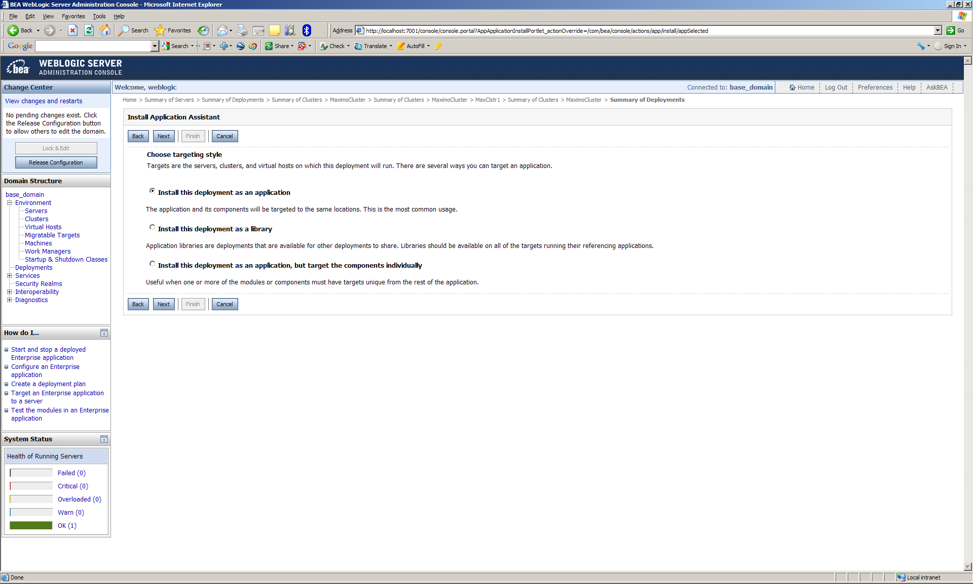

  - Select the Maximo Cluster and All servers in the cluster and click Next

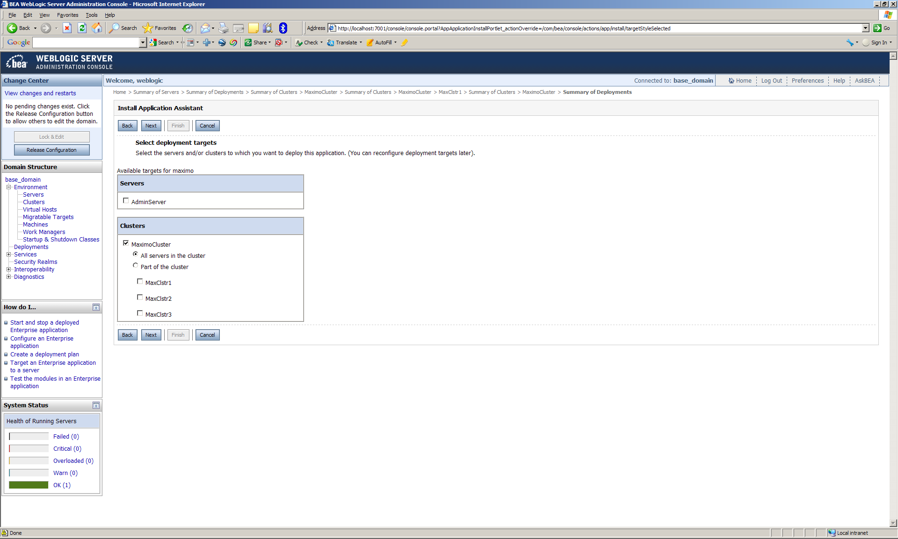

  - Accept the default and click Next

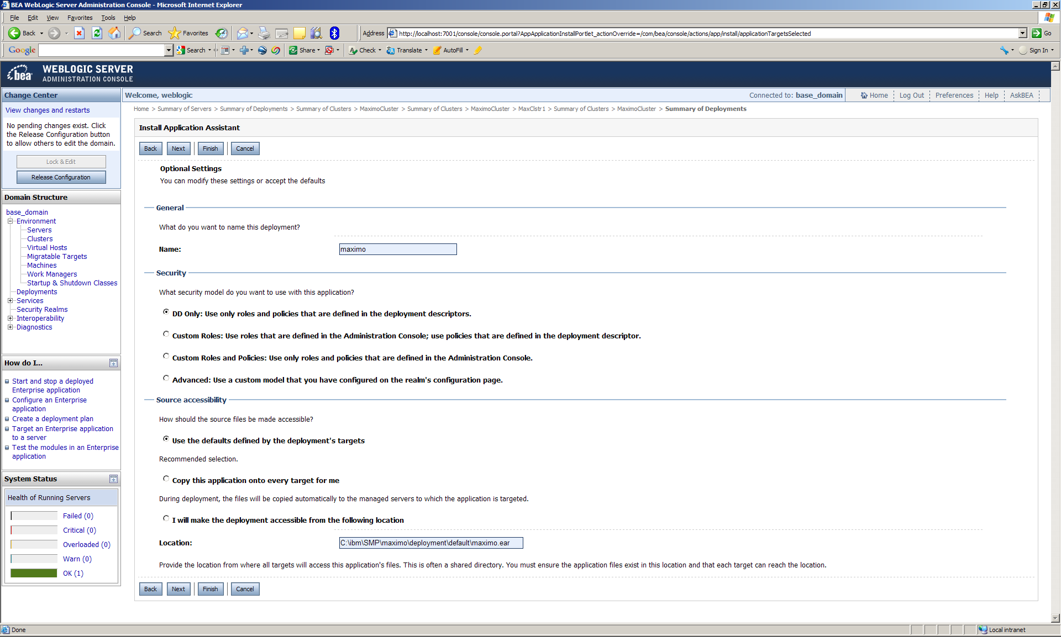

  - Accept the default and click Finish

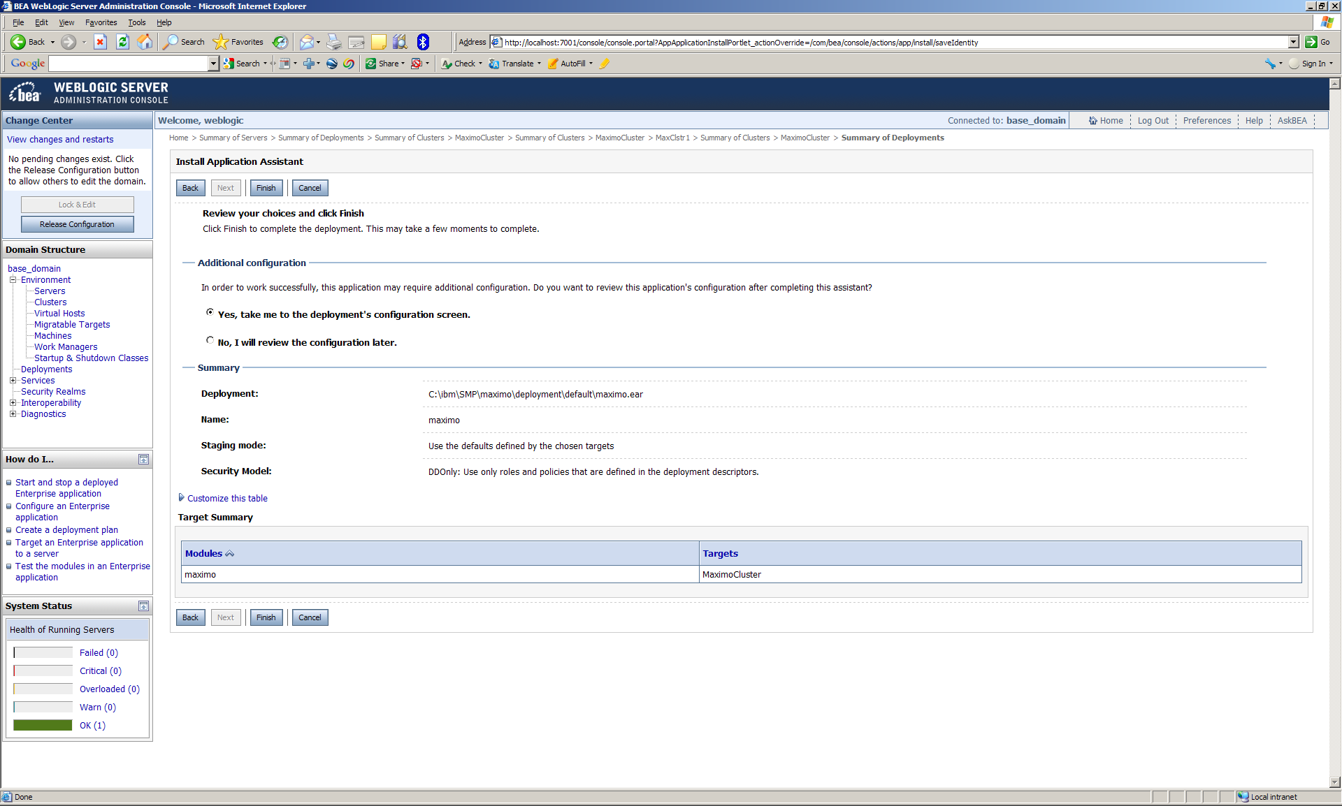

  - Click Save

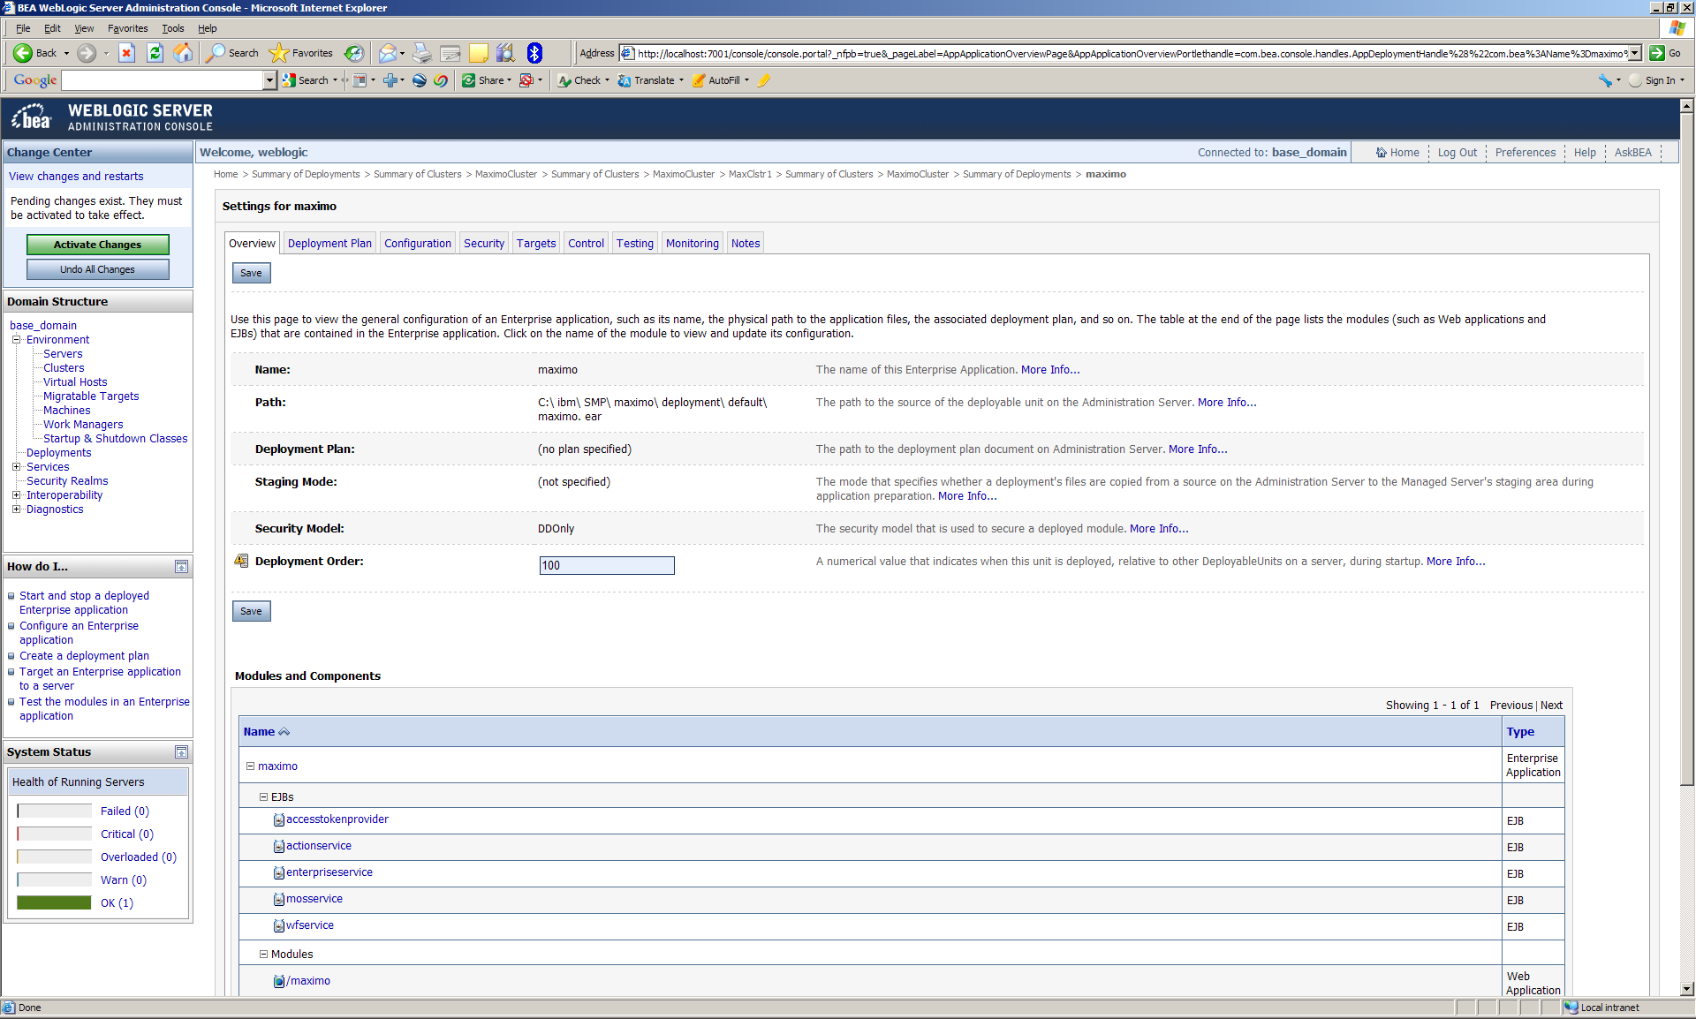

  - Repeat for the Maximo help EAR
  - Click Activate Changes

- Start the Cluster
  - Start the Admin Server
    - From a command prompt change to bea\user_projects\domains\base_domain
    - Run startweblogic
  - Start the Managed Servers
    - From a command prompt change to bea\user_projects\domains\base_domain\bin
    - Run startmanagedweblogic <server> <admin ur>
i.e. startmanagedserver MaxClstr1 http://servername:7001
    - Repeat for each cluster member

Notes

- When deploying more than 1 Maximo application server on a physical server create RMI as a separate application server.

  - Understanding the Maximo Implementation of Java Remote Method Invocation
https://www-304.ibm.com/support/docview.wss?uid=swg21262022

  - Deploying the RMI Registry (rmireg.war) in WebLogic for Windows
https://www-304.ibm.com/support/docview.wss?uid=swg21290829

- Other support documents regarding Maximo clustering

  - Clustering with Integration Framework - WebLogic 9 and Maximo 7
https://www-304.ibm.com/support/docview.wss?uid=swg21396723

  - Building different maximo.ear files from one Maximo installation folder
https://www-304.ibm.com/support/docview.wss?uid=swg21450028

  - Take Control of JVM Names for Instance, Cron and Log Names Using -Dmxe.name
https://www-304.ibm.com/support/docview.wss?uid=swg21446387

